Requirements for Reconfiguration of MAST Application Suite for Burkina Faso

Mobile Application to Secure Tenure (MAST)

Contents

[1. INTRODUCTION 1](#_Toc468195291)

[1.1 About document 1](#_Toc468195292)

[1.2 In this Document 1](#_Toc468195293)

[1.3 Purpose 1](#_Toc468195294)

[2 CONTEXT FOR MAST IN BURKINA FASO 2](#_Toc468195295)

[2.1 Existing Business Processes and Actors 2](#_Toc468195296)

[2.2 MAST in Burkina Faso 4](#_Toc468195297)

[2.2.1 Mobile Application 4](#_Toc468195298)

[2.2.2 DMI 5](#_Toc468195299)

[3 Mobile Application to Secure Tenure (MAST) 9](#_Toc468195300)

[3.1 MAST Components 9](#_Toc468195301)

[3.2 Deployment 9](#_Toc468195302)

[3.3 Users and Characteristics 11](#_Toc468195303)

[3.3.1 User Description 12](#_Toc468195304)

[3.3.2 User Action/Roles 13](#_Toc468195305)

[4 Work Processes 15](#_Toc468195306)

[4.1 APFR Registration Process Systematic 15](#_Toc468195307)

[4.2 Existing Titles 22](#_Toc468195308)

[5 Software Requirements 26](#_Toc468195309)

[5.1 Mobile Application 26](#_Toc468195310)

[5.2 DMI 27](#_Toc468195311)

[5.2.1 Land Record Dashboard 27](#_Toc468195312)

[5.2.2 Land Records Management (Workflow) 28](#_Toc468195313)

[5.2.3 Identifiers and Land Record Search Functionality 29](#_Toc468195314)

[5.2.4 Data Visualization (land record) 29](#_Toc468195315)

[5.2.5 Data Visualization (Mapping View) 30](#_Toc468195316)

[5.2.6 Reporting 31](#_Toc468195317)

[6 Use Case 33](#_Toc468195318)

[6.1 Mobile Data Capture Application 33](#_Toc468195319)

[6.1.1 Use Case-MTP -01: Authentication 33](#_Toc468195320)

[6.1.2 Use Case-MTP -02: Download Configuration Data 35](#_Toc468195321)

[6.1.3 Use Case-MTP -03: Map Viewer 36](#_Toc468195322)

[6.1.4 Use Case-MTP -05: Capture Data 37](#_Toc468195323)

[6.1.5 Use Case-MTP -06: Spatial Data Capture Tools 38](#_Toc468195324)

[6.1.6 Use Case-MTP -09: Capture Attribute Data 39](#_Toc468195325)

[6.1.7 Use Case-MTP -10: Capture Property Multimedia Information 43](#_Toc468195326)

[6.1.8 Use Case-MTP -11: View/Edit Multimedia Information 44](#_Toc468195327)

[6.1.9 Use Case-MTP -07: Edit Spatial Data 44](#_Toc468195328)

[6.1.10 Use Case-MTP -08: Delete Data 45](#_Toc468195329)

[6.1.11 Use Case-MTP -04: Review Data 46](#_Toc468195330)

[6.2 WEB Application (DMI) 47](#_Toc468195331)

[6.2.1 Use Case-MTP -12 SFR Role- Functionalities 47](#_Toc468195332)

[6.2.2 Use Case-MTP -12 DPI Role 54](#_Toc468195333)

[7 Data Model 57](#_Toc468195334)

[7.1 Mobile Application 57](#_Toc468195335)

[7.2 DMI- Data Management Infrastructure 59](#_Toc468195336)

[7.2.1 action 60](#_Toc468195337)

[7.2.2 adjacent\_property 60](#_Toc468195338)

[7.2.3 attribute 60](#_Toc468195339)

[7.2.4 attribute\_category 60](#_Toc468195340)

[7.2.5 attribute\_master 60](#_Toc468195341)

[7.2.6 attribute\_options 61](#_Toc468195342)

[7.2.7 baselayer 61](#_Toc468195343)

[7.2.8 bookmark 62](#_Toc468195344)

[7.2.9 citizenship 62](#_Toc468195345)

[7.2.10 commune 62](#_Toc468195346)

[7.2.11 Cosmetic\_Line 62](#_Toc468195347)

[7.2.12 Cosmetic\_Point 63](#_Toc468195348)

[7.2.13 Cosmetic\_Poly 63](#_Toc468195349)

[7.2.14 datatype\_id 63](#_Toc468195350)

[7.2.15 education\_level 63](#_Toc468195351)

[7.2.16 gender 64](#_Toc468195352)

[7.2.17 group\_person 64](#_Toc468195353)

[7.2.18 group\_type 64](#_Toc468195354)

[7.2.19 land\_type 64](#_Toc468195355)

[7.2.20 land\_use\_type 64](#_Toc468195356)

[7.2.21 layer 65](#_Toc468195357)

[7.2.22 layer\_field 66](#_Toc468195358)

[7.2.23 layer\_layergroup 66](#_Toc468195359)

[7.2.24 layergroup 67](#_Toc468195360)

[7.2.25 layertype 67](#_Toc468195361)

[7.2.26 maptip 67](#_Toc468195362)

[7.2.27 marital\_status 68](#_Toc468195363)

[7.2.28 module 68](#_Toc468195364)

[7.2.29 module\_action 68](#_Toc468195365)

[7.2.30 module\_role 68](#_Toc468195366)

[7.2.31 mutation\_type 69](#_Toc468195367)

[7.2.32 natural\_person 69](#_Toc468195368)

[7.2.33 nature\_of\_application 70](#_Toc468195369)

[7.2.34 nature\_of\_power 70](#_Toc468195370)

[7.2.35 non\_natural\_person 71](#_Toc468195371)

[7.2.36 nonspatial\_attachment 71](#_Toc468195372)

[7.2.37 occupancy\_type 71](#_Toc468195373)

[7.2.38 outputformat 72](#_Toc468195374)

[7.2.39 overviewmap 72](#_Toc468195375)

[7.2.40 parcel\_type 72](#_Toc468195376)

[7.2.41 person 72](#_Toc468195377)

[7.2.42 person\_administrator 73](#_Toc468195378)

[7.2.43 person\_type 73](#_Toc468195379)

[7.2.44 printtemplate 73](#_Toc468195380)

[7.2.45 project 73](#_Toc468195381)

[7.2.46 project\_adjudicators 75](#_Toc468195382)

[7.2.47 project\_area 75](#_Toc468195383)

[7.2.48 project\_baselayer 76](#_Toc468195384)

[7.2.49 project\_hamlets 76](#_Toc468195385)

[7.2.50 project\_layergroup 77](#_Toc468195386)

[7.2.51 project\_region 77](#_Toc468195387)

[7.2.52 project\_spatial\_data 77](#_Toc468195388)

[7.2.53 projection 78](#_Toc468195389)

[7.2.54 province 78](#_Toc468195390)

[7.2.55 raster\_columns 78](#_Toc468195391)

[7.2.56 raster\_overviews 79](#_Toc468195392)

[7.2.57 region 79](#_Toc468195393)

[7.2.58 role 79](#_Toc468195394)

[7.2.59 savedquery 80](#_Toc468195395)

[7.2.60 share\_type 80](#_Toc468195396)

[7.2.61 slope\_values 80](#_Toc468195397)

[7.2.62 social\_tenure\_relationship 80](#_Toc468195398)

[7.2.63 soil\_quality\_values 81](#_Toc468195399)

[7.2.64 source\_document 81](#_Toc468195400)

[7.2.65 spatial\_ref\_sys 82](#_Toc468195401)

[7.2.66 spatial\_unit 82](#_Toc468195402)

[7.2.67 spatialunit\_deceased\_person 84](#_Toc468195403)

[7.2.68 spatialunit\_personwithinterest 84](#_Toc468195404)

[7.2.69 structure\_facility 85](#_Toc468195405)

[7.2.70 style 85](#_Toc468195406)

[**sunit\_status** 85](#_Toc468195407)

[7.2.71 sunit\_workflow\_status\_history 85](#_Toc468195408)

[7.2.72 surveyprojectattributes 86](#_Toc468195409)

[7.2.73 task 86](#_Toc468195410)

[7.2.74 task\_scheduler 86](#_Toc468195411)

[7.2.75 tenure\_class 86](#_Toc468195412)

[7.2.76 unit 87](#_Toc468195413)

[7.2.77 user\_project 87](#_Toc468195414)

[7.2.78 user\_role 87](#_Toc468195415)

[7.2.79 users 88](#_Toc468195416)

[7.2.80 vertexlabel 88](#_Toc468195417)

[7.2.81 village 88](#_Toc468195418)

[7.2.82 workflow 89](#_Toc468195419)

[7.4 Land Rights Application and Documents 90](#_Toc468195420)

[7.4.1 Form 1: Demande de constatation de possession foncière rurale à titre individuel ou collectif (Form 1 – Application form for individuals of collective) 90](#_Toc468195421)

[7.4.2 Form 2: Formulaire de Mandat pr demande collective\_final\_KDG\_validé Mandate for collective application) 91](#_Toc468195422)

[7.4.3 Form 3: Formulaire\_avis\_publicté foncière\_final\_KDG\_validé (Public Notice) 92](#_Toc468195423)

[7.4.4 Form 7: PV de Constatation Contradictoire 93](#_Toc468195424)

[7.4.5 Form 5. Fomulaire\_Attest\_Poss\_Fonc\_ individuelle initiale\_final\_KDG\_validé (Individual APFR) 95](#_Toc468195425)

[7.4.6 Form 8: Formulaire Attest\_Poss\_Fon\_Rurale\_collective\_final\_KDG\_validé (Collective APFR) 96](#_Toc468195426)

[7.5 Attributes of key Land Forms 97](#_Toc468195427)

[7.6 Registry Forms 118](#_Toc468195428)

[7.6.1 Attributes of Registry 120](#_Toc468195429)

# INTRODUCTION

## About document

This document provides a quick synopsis of specifications for the deployment of MAST in Burkina Faso. It does not detail complete user and system requirements for the technology, but rather highlights key land administration process and the required system modifications required to satisfactorily complete processes in a more efficient and expedited manner.

The automation of the APFR registration processes will involve the reconfiguration of the Mobile Application to Secure Tenure (MAST) software application suite for the deployment of an initial APFR registration system.

The main audience members of this document are the ERC developers, which is contracted to RMSI, and the user agency stakeholders the ONF-BF, the SFR and the Regional Cadastral Department of the Central Plateau.

## In this Document

This document describes key work processes, existing and modified for use of the MAST technology suite, as well as software requirements as it relates to the extension of the MAST software application suite for its deployment in Burkina Faso.

## Purpose

The purpose of this document is to define the requirements for stakeholders, and once it is accepted by all undersigned parties, it shall represent the full scope of the MAST for Burkina Faso. This specification document represents definitions received by CORE team stakeholders during a visit to Burkina Faso August 1-10, 2016.

# CONTEXT FOR MAST IN BURKINA FASO

## Existing Business Processes and Actors

The formal registration of rural property rights is provided through several different actors in Burkina Faso and is based on Law 34-2009. This legislation decentralized the land administration processes and codifies principles of customary rights by enabling communities to gain rights through rural land charters.

The land charters contain rules related to the accessing possession rights to lands, and were designed to in a participatory manner to include a representative group of stakeholders (including women, forest users, pastoralists, and youth, etc). It provided for the recognition of individual and collective land rights, the transfer of certificates of rural land possession through inheritance, oral and written rural land leases, and the creation of local land management institutions. Key processes are to be aided by the state through local land institutions. These include:

* Service Foncier Rural (Rural Land Service), a national institution represented in each commune;
* Commissions Villageoises Foncière (Village Land Commissions);
* Commission de Conciliation Foncière Villageoise (CCFV); and
* Regional Cadastral Department (formerly DPI)

Under the new law, individuals or groups of individuals (usually families) may request a certificate of possession rights, which is documented in the Attestation de Possession Foncière Rurale (AFPR, or Rural Land Possession Certificate).

The process is designed to take only 75 days if no objections are raised. The reality is that the timeline for the implementation of this process is quite different. This process is initiated at the village level and the application is sent to the SFR for review and for checks on whether there no possession or property titles on the parcel. This process is done by the SFR in consultation with regional cadastral department (formerly the DPI). In the case when there are no competing claims, the parcel is cleared for adjudication and sent to the village where it is publically displayed for a period of 45 days. If there is no objection through the public notification, land record documents are executed and the SFR prepares an APFR for signature by the Mayor of the commune.

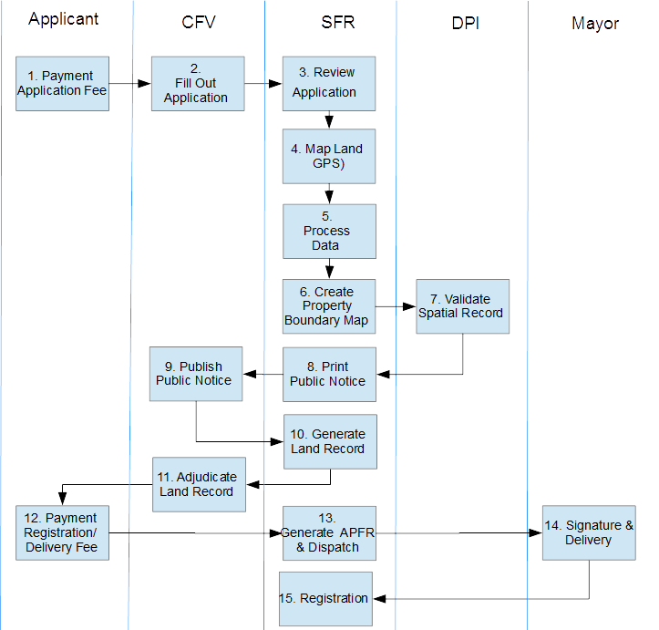

1. Pay application and delimitation fee at commune to process application and survey land.
2. Present documentation and fill out application form with CFV at village for APFR registration.
3. Review application at SFR.
4. Conduct field mapping with GPS
5. Process data and integrate GPS data into a GIS
6. Finalize and a cadastral or property boundary map and send to the DPI for validation.
7. Validate property boundary map against record of titles and possessions at the DPI.
8. Create and print public notice and send to CFV for public consultation.
9. Publish notice at the CFV for period of 45 days.
10. Create formal land record for execution by all parties at village level.
11. Execute and adjudicate land record at village level and send back to SFR.
12. Payment of registration fee by applicant.
13. Create and print file APFR and dispatches it to Mayor for signature.
14. Signs and stamps APFR documents.
15. Registers APFR and returns a registered copy to applicant.

## MAST in Burkina Faso

It is envisaged that MAST will be utilized for capturing information in the field with mobile phones, providing enhanced visualization tools for verifying and validating data and provide the ability for users to generate and print a series of template reports. The APFR process, while being consistent with the Law 34-2009, will be standardized to automate and administer the process of registering APFRs. The base architecture and data model will for the most part stay the same, but there will be enhanced workflow management and reporting functions integrated into the software application.

A simple description of proposed enhancements is provided in the table below.

### Mobile Application

| **#** | **Required Functional Area/Component** | **MODIFICATION DESCRIPTION** |
| --- | --- | --- |
|  | Data Capture | MAST will be configured to capture new parcels, those parcels that do not have APFRs or titles, and parcels that have existing titles, but no APFRs.  New Parcels – will follow workflow that captures spatial data and full set of attributes required to fill out land forms documents. Tenure types are different (individual and collective) so different business rules for   * Individual you follow-Form 1 * Collective – you follow-Form 1 and then fill out Form 2 to identify other persons of interest   Existing parcels – will follow a simplified process, and data capture for those parcels will require spatial data capture and a minimal set of attributes. |
|  | Data Capture Categories | Mobile phones will be configured to same categories:   * General * Property * Tenure * Person – there is no pictures required for persons * Multi-media |
|  | External GPS | Garmin Glo & Bad Elf Pro/Pro+ are to be verified and tested for integration. |

### DMI

| **#** | **Required Functional Area/Component** | **MODIFICATION DESCRIPTION** |
| --- | --- | --- |
|  | **Land Record Management Dashboard Modification** | This will require modification of attributes to match local level registration such as Form 33. So as to be applicable to local context.   1. Application Number 2. PV Number 3. Name 4. Last Name 5. Parcel Type (New, existing) 6. Application Type (individual or collective) |
|  | **Enhanced System Workflow** | There is a requirement for the integration and management of a more complex workflow MAST BF. It is envisioned that data will move from the field into the DMI and then through several different stages until formal registration. Key processes will be performed outside of the system, and the user will need the ability to update the status – approve or update the status of the transaction record to move it to the next stage, or conversely reject it and move it to the previous stage. Multiple agencies will also utilize the system so user management needs to take into account rights and privileges of users from the SFR and DPI. |
|  | **Transaction Tracking** | There should be the possibility of transaction based functionality for the tracking of application through a series of stages or registration activities. Simple tracking of completed transactions or the status of transactions will be necessary. Status of transactions will be new, in progress and completed. MAST will also need to keep track and integrate work processes that are internal and external to the system. |
|  | **Identifiers and Land Record Search Functionality** | There is a need to improve functionality to allow users to search features in the MAST DB according to their attribute values. Current version of MAST TZ allows only search criteria by parcel number only. This functionality needs to be expanded for key identifiers and also by status. |
|  | **Visualize, Edit and Save Attributes** | Once a land record is selected and opened, user will have options to view and edit spatial and attribute data. Visualization and editing tools shall provide same functionality as currently available (pop-up window with tabs). New tabs for visualization of attributes will be required. |
|  | **Map Viewer, Layer Management** | MAST DMI will be required to show the display and manage of several data layers. These include:   * Spatial Unit captured as part field mapping from mobile phone (editable layer); * Existing APFRs (spatial layer = used for reference purposes). * Existing Titles (spatial layer = used for reference purposes) * Commune Base data (roads, village names, etc.) * Commune Sections – used for parcel number generation. * Imagery |
|  | **Map Viewer, Zoom Levels** | The map zoom function is currently restricted at levels – this functionality should not be restricted to levels but should have a maximum and minimum zoom level defined. |
|  | **Map Viewer (tool bar access)** | There is a need to change access to tools either as floating or a lockable tool set. It will help also if tools were broken into logical groupings – i.e. visualization, editing, advanced editing, etc. |
|  | **Map Viewer (thematic display)** | **Thematic Display Functions**  Thematic display functions are required to display parcels by status, gender, or any other attribute value |
|  | **Map Layouts, Verification and Mapping** | Map Layout for Verification  May layout Presentation |
|  | **Map Layouts, Reports** | Property Boundary Map |
|  | **Reporting Tools, Template reports** | A series of forms will be generated by MAST for specific property. These forms follow a legal and pre-defined format:   * Form 1: Demande de constatation de possession foncière rurale à titre individuel ou collectif (Application form for individuals of collective) * Form 2: Formulaire de Mandat pr demande collective\_final\_KDG\_validé Mandate for collective application) * Form 3: Formulaire\_avis\_publicté foncière\_final\_KDG\_validé (Public Notice) * Form 7: PV de Constatation Contradictoire * Parcel Boundary Map (need copy) * Form 5. Fomulaire\_Attest\_Poss\_Fonc\_ individuelle initiale\_final\_KDG\_validé (Individual APFR) * Form 8: Formulaire Attest\_Poss\_Fon\_Rurale\_collective\_final\_KDG\_validé (Collective APFR) * Payment Request Letter – which will be a form letter where values are entered and values are saved, however, there will be no calculations |
|  | **Reporting Tools, Statistical Reports** | MAST shall support the generation of statistical reports for reporting purposes. These can be database views, which can be extracted as CSV:  **Map register**   * number of spatial units mapped, by tenure * number of spatial units mapped, by gender   **Application register**   * number of application processed,by Tenure * number of application processed, by gender   **APFR register**   * number of APFR printed, by tenure * number of APFR printed, by gender |

# Mobile Application to Secure Tenure (MAST)

## MAST Components

The MAST application provides a suite of applications to support collection and management of land rights information with a mobile application to capture land rights information in the field and a back-end land rights data management infrastructure application with tools to manage an inventory of land information.

The key components of MAST Framework are:

* **Mobile Data Capture Application** – Key component of MAST Framework is Android based Mobile application that is focused on the capture of land rights information (spatial, alphanumeric and multimedia). The Mobile application allows for the collection of data without being connected to a central cloud based server in offline mode. Data is collected and stored on users’ handheld device, and once the user is within the influence region of the internet, data can be synced and sent back to the server.
* **Land Rights Data Management (Web) Application** – MAST data capture application is provided with a back-end web application which provides the facility to configure the mobile application, manage data collection projects, and manage land rights information data that has been collected in the field. Key modules of web application are:   
  + Configuration Tool – The Web based configuration tool provides the facility to configure the land rights data collection mobile application. Configuration tool provides the facility to configure the attribute fields of data collection form that are collected in the field. This enables the land rights information survey exercise to be performed in multiple environments by configuring the data collection form for the specific needs of the area, for a specific project.
  + Administration Tool – The Administration tool provides the facility to manage users, roles; import and configure data layers; configure layer groups; configure survey projects; and configure master attributes that can be used in projects. This module facilitates in creation and configuration of survey projects, and the association of layer groups and users.
  + Data Management Infrastructure – The Data collected on mobile devices is transferred to a cloud based Data Management application, which provides tools to ingest, manage and store data of land rights information. It also provides mapping tool as well as reporting components so that required Land Rights reports can be generated.

## Deployment

The proposed network infrastructure will take advantage of cloud computing resources for the deployment of MAST. It is anticipated that SFR agents will oversee and validate land rights data that is captured by trusted intermediaries in the field. Mobile phones will be used to capture land rights data and data will be stored on devices until there is ample connection to sync data via available 3G/Internet connections to the MAST Data Management Infrastructure (DMI). Data will be accessed by SFR agents via 3G/Internet connections and will be reviewed, edited, validated before being transferred to DMI. Adjudication will occur through the generation of template reports such as APFR application forms, land record forms and eventually the APFR. The diagram below shows a conceptual deployment of MAST in Boudry Commune.

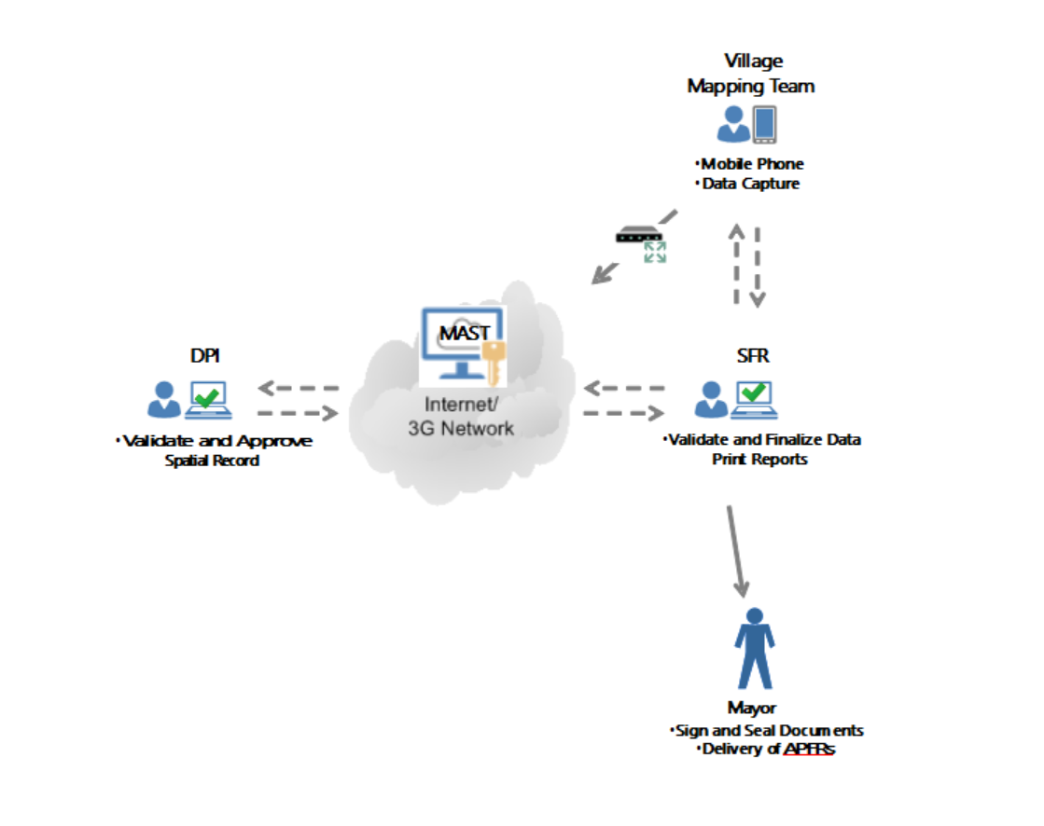

The DMI will be setup as follows:

|  |  |  |
| --- | --- | --- |
| **ADMINISTRATIVE BOUNDARY** | **DEFINITION** | **DESCRIPTION** |
| Country: | Burkina Faso | * 13 Regions. Each region have several Province. * 45 Provinces. Each province have several Communes. * 351 Communes (301 rurals and 49 urbans). Each commune have several villages (or sector in urban communes) |
| Région : | Plateau-Central | A region can have rural and urban communes. We are only concerned with rural lands with MAST. Regions in Burkina are:   * Boucle du Mouhoun * Cascades * Centre * Centre-Est * Centre-Nord * Centre-Ouest * Centre-Sud * Est * Hauts-Bassins * Nord * Plateau-Central * Sahel * Sud-Ouest |
| Province : | Ganzourgou | The region of “Plateau central” have 03 provinces :   * Ganzourgou, * Kourwéogo, * Oubritenga |
| Commune: | Boudry | Bourdy is one of the 07 communes of Ganzourgou ( [Boudry](https://fr.wikipedia.org/wiki/Boudry_%28d%C3%A9partement%29), [Kogho](https://fr.wikipedia.org/wiki/Kogho_%28d%C3%A9partement%29), [Méguet](https://fr.wikipedia.org/wiki/M%C3%A9guet_%28d%C3%A9partement%29), [Mogtédo](https://fr.wikipedia.org/wiki/Mogt%C3%A9do_%28d%C3%A9partement%29), [Salogo](https://fr.wikipedia.org/wiki/Salogo_%28d%C3%A9partement%29), [Zam](https://fr.wikipedia.org/wiki/Zam_%28d%C3%A9partement%29), [Zorgho](https://fr.wikipedia.org/wiki/Zorgho_%28d%C3%A9partement%29),,[Zoungou](https://fr.wikipedia.org/wiki/Zoungou_%28d%C3%A9partement%29))  Boundary of Commune has been provided to MAST team by the Cadastral Department. |
| Section | Numerical | Arbitrarily defined |
| Village: | * Ouayalgui 1 * Ouayalgui 2 * Ouayalgui 3 * Ouayalgui 4 | There are 84 villages in Boudry. These villages are treated as hamlets in Tanzania.  Provide list of all villages, but only allow users to select one of the 4 villages. |

## Users and Characteristics

### User Description

|  |  |  |
| --- | --- | --- |
| ROLE NAME | DESCRIPTION | GROUP NAME |
| CFV Agent | CFV agents will be selected by the CFV members and trained to use MAST to collect land rights data in the field using the MAST mobile application. They will capture spatial and attribute information of spatial units in the field. They will also verify the data before transferring the collected to the backend Data Management Infrastructure. The data captured by the CFV agent will utilize be reviewed and marked as complete by SFR agent. | Data Collector (producer) |
| SFR Land Official (office) | These are regional government officials that are charged with the management land affairs for the national government. They will access the DMI to review, edit and validate spatial and tabular data. They will also be in-charge of tracking of the MAST land record transaction throughout the process. In certain stages of the workflow, they are in-charge of generating and printing reports that will be used in the formalization of land rights. They will have full access of data for a designated survey project. | Designated Land Office |
| DPI Land Official (office) | The DPI is the regional cadastral agency in-charge of validating the land records. Designated users will access MAST and have access to limited land record dashboard, which will contain a queue of spatial records that are to be ready for an opinion. The DPI agent will approve or reject the property boundary map. They will require access to spatial records to view selected parcel in relations to APFRs and titles. They will have limited access to the designated survey project and limited review of data in the spatial land record. They will require access to review parcel data, parcel geometry and export coordinates so as to recreate parcel in 3rd party software. | Designated Land Office |
| Project Manager | The Project Manager will have full access to entered data into the MAST database. He or she will use the DMI to review and edit data. He or she will have full permissions to add, delete, or modify data. The primary function will be to validate data that has been committed to the MAST database, and work alongside both the SFR and DPI. Project manager will also have access to statistical reports and database views. | Manager |
| System Administrator | The system administrator will be a super-user and is the administrator of the MAST framework. This person will have access rights to the MAST framework, which will be housed on amazon. The administrator will have full access permissions of all the functionalities of application including all data and will be in charge of system maintenance. They will be responsible for master data management, establishing and managing MAST projects, managing users and allocating roles and responsibilities to the users. The system administrator will also be responsible for configuring and loading data and defining data collection forms for specific survey projects. | Manager |

### User Action/Roles

|  |  |  |  |  |  |  |  |  |  |  |  |  |  |
| --- | --- | --- | --- | --- | --- | --- | --- | --- | --- | --- | --- | --- | --- |
|  | **Group Name** | **Mobile data capture** | **View Land record** | **Edit Land record** | **View Map** | **Edit Map** | **Generate**  **& print**  **Application** | **Generete**  **& print**  **Boundery map** | **Query**  **& view**  **registery** | **Query**  **& view**  **stat** | **Edit Cadastral Opinion** | **View cadastral opinion** |  |
| CFV agent | Data Collector (producer) | x |  |  |  |  |  |  |  |  |  |  |  |
| SFR Land Official (office) | Designated Land Office |  | x | x | x | x | x | x | X | x |  | x |  |
| DPI Land Official (office) | Designated Land Office |  | x |  | x |  |  | x | x | x | **x** |  |  |
| Project Manager | Manager |  | x |  | x |  | x | x | x | x |  | x |  |
| System Administrator | Manager |  | x | x | x |  | x | x | x | x | x | x |  |

# Work Processes

This section describes the business processes that have been identified for configuration of MAST for Burkina Faso.

[Expand introduction here]

Orange = Processes on Mobile Application

Yellow = Processes on DMI

Blue = Processes not on System

## APFR Registration Process Systematic

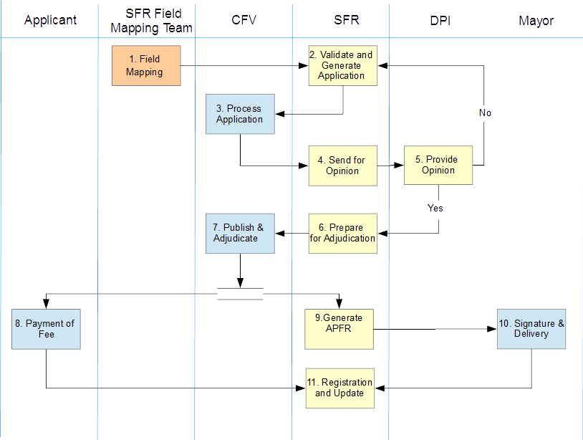

| **#** | **Activity** | **Description/Business Context** | **System (Inputs & Outputs)** |
| --- | --- | --- | --- |
|  | Field Mapping (Pre-adjudication) | General Description CFV agent initiates process for the collection of land rights information. The MAST mobile application is used to capture spatial information. After spatial data capture, user follows a series of attribute forms for the capture of general, property, tenure and personal information. There are two types of occupancy types – individual and collective.  Typical operations on this stage   * Confirms Data Capture Type to initiate data capture on mobile device. * Through discussions with occupant, and the walking of physical boundaries of the property, the CFV agent will capture parcel boundaries by capturing the coordinate corners of parcel boundaries. The spatial data is saved to mobile phone. * After capture of spatial unit, the attribute for selected data type will be opened and the CFV agent will fill in appropriate attribute forms for data capture type (individual or collective). * After editing, data (spatial and attribute) is saved and stored on the mobile device. * Reviewed and/or corrected spatial units and associated attribute data captured in the field is reviewed and edited and marked as complete for transfer to DMI | Input Data   * Activation of data capture type (new) * New GIS parcel boundary feature; * Spatial unit number will be automatically defined on phone to facilitate importation;   Output Data   * Collection of spatial data * Collection of attribute data |
|  | Validate and Generate Application | General Description  SFR users will review a listing of land records (DMI dashboard). This listing should be consistent with the format of registries used at the SFR (See Form 33). From a tabular view, users will select a record and review the technical information that was collected in the field during the survey (spatial and tabular). Attention will be given to verifying spatial and tabular data.  If problems are encountered with spatial record, the user will print a map for verification along with a tabular print out of all attributes (note that we need a more thorough print out of attributes consistent with Form 1 or 2). Map layout view (note should include multiple parcels and be printed in a standard map layout).  The SFR agent will then use the tabular and map layout to validate the data in the field. Notations and corrections are made on the paper map, and tabular forms. Once data is validated in the field spatial and attribute data is updated for a particular land record is updated on the DMI.  From a tabular view, the SFR agent will select the print/reporting tool to generate an application form.  ***If individual = Form 1 Formulaire DEMANDE Constataion de Possesion Foncière Rurale final KDG validé***  If Collective=  ***Form 1 Formulaire DEMANDE Constataion de Possesion Foncière Rurale final KDG validé***  and  ***Form 2 Formulaire de Mandat pr demande collective final KDG validé.***  Once the application form has been generated and printed, the status will be changed to allow users to understand that application has been printed for that particular land record. An application number is generated for the land record.  A group of application forms are dispatched and a dispatch table or registry (Form 33) will be printed to facilitate the dispatch and management of application forms at the village level.  Typical operations on this stage   * Review listing of land records created by data that has been imported into system. * Select land record (imported data shown in DMI dashboard, each land record represents a transaction in the system) * Review information – spatial units and attributes; * Update spatial record (edit to parcel using standard GIS tools); * Update Attributes (edit attribute data); * Print map and tabular layout for field verification; * Update land record based on field visit, which may include edit to spatial and tabular data. * Generate Application Form Template, which contains important applicant and property information. * Approve Workflow stage and move to “Process Application Stage”. | Input Data   * Spatial and tabular land record data captured in the field (transaction record).   Output Data   * Map and tabular layout of land record data * APFR Application, according to occupancy type   + ***Form 1 Formulaire de DEMANDE Constataion de Possesion Foncière Rurale final KDG validé***   + ***Form 2 Formulaire de Mandat pr demande collective final KDG validé*** |
|  | Process Application | General Description  The majority of the work process is outside of the system.  The CFV agent will review the application form and validate information. The applicant will submit required documentation (birth certificate and national identification card) to CFV.  If information is validated, the application form will be executed by applicant, witnessed and counter signed by CFV agent. The validated form will be reviewed, and the SFR agent will approve stage and send for an opinion stage.  Errors will be sent back to SFR, where updates are made to transaction record and application forms are reprinted.  Typical operations on this stage   * Edit, update and reprint application form * Approve application stage, and work transaction record to “send for an opinion” stage | Input Data   * None   Output Data   * Executed Application Form (Paper Copy). * Validated applications will be sent to the SFR with a dispatch form (this could be same dispatch form sent from the SFR with check marks indicating which applications have been validated or which applications require correction). |
|  | Provide Opinion | General Description  The DPI agent will review only a land records that are in the send for an opinion stage and provide an opinion.  To provide an opinion, the DPI agent will select and review transaction record, view parcel map, specifically if the parcel is overlapping any APFR or Titles. The attributes of the transaction record will be reviewed, especially the coordinate geometry of parcel (coordinates). The coordinates will be exported in CSV format, if desired.  Note: to facilitate this review, the MAST spatial unit layer will be shown with: a) existing shapefile of existing APFRs, b) existing shapefile of land titles, c) base data, and d) imagery.    Upon the successful validation of spatial record, the DPI agent approves the property boundary map (selects radio button) and makes a notation of notes (text box). If it is not approved, the transaction is rejected at this time and notation is made. An approved or rejected record is removed from DPI queue.  Typical operations on this stage   * Search, review and retrieve MAST transaction record – spatial and tabular * Select MAST transaction record or transaction * Review information spatial and tabular * Generate and print Property Boundary Map * Approve or Reject Property Map * Transaction is moved to new workflow stage – “Prepare for Adjudication” | Input Data   * Transaction record   Output Data   * Updated and Approved (not approved) property record * Property Boundary Map (hard copy for their record) |
|  | Prepare for Adjudication | General Description The SFR agent will select and review MAST transaction record, and review any notations that have been added by the DPI. The SFR agent generates and prints four important documents:   1. Public notice (***Form 3: Formulaire\_avis\_publicté foncière final KDG validé).*** 2. Land Record (like adjudication form in Tanzania) ***Form 7: PV de Constatation Contradictoire –*** *(an* adjudication number is assigned to Form 7) 3. Payment Request Letter**(to be formatted); and** 4. Property Boundary Map   Note: Since these documents will likely be printed and sent in batches, again a simple registry or dispatch table may be required to help village officials in the management of these forms at the village level.  Typical operations on this stage   * Select approved MAST transaction record (land records that have been validated) * Generate public notice (***Form 3: Formulaire\_avis\_publicté foncière final KDG validé)*** * Land Record (like adjudication form in Tanzania) ***Form 7: PV de Constatation Contradictoire) and assign an adjudication number to PV*** * Payment Request Letter**(to be formatted)** * **Property Boundary Map** (hard copy is printed and saved in SFR land record file) | Input Data   * MAST Transaction Record   Output Data   * Public Notice (***Form 3: Formulaire\_avis\_publicté foncière final KDG valide)*** * Land Record (like adjudication form in Tanzania) ***Form 7: PV de Constatation Contradictoire)*** * Payment Request Letter**(to be formatted)** * **Property Boundary Map** |
|  | Publish and Adjudicate | General Description  The CFV receives a batch of public notices, PV forms, and payment letters and a dispatch table or registry, and publishes the notice. It must remain published for 45 days according to law.  Once the 45 day public notification period has past, and there are no objections to the land record, formal adjudication of the land can occur.  To formalize or adjudicate the land record, the PV form (form 7) is executed by the applicant, neighbors and the CFV. Once they execute PV form is executed, the applicant will be given the payment request letter.  The executed PV forms will be sent back to the SFR, where the SFR will approve the adjudication and move the transaction record to the “generate APFR stage”    Typical operations on this stage   * Approve application stage, and work transaction record to “generate APFR stage” | Input Data   * Public Notice (***Form 3: Formulaire\_avis\_publicté foncière final KDG valide)*** * ***Form 7: PV de Constatation Contradictoire)*** * Payment Request Letter**(to be formatted)**   Output Data   * None |
|  | Payment of Fee | General Description  This work process is outside of the system. The applicant will take his/her payment request letter to the RDPF at the commune and pay fees. They will receive receipts as evidence of payment which will be used to obtain their copy of APFR.  Typical operations on this stage  None – Not in System | Input Data   * None   Output Data  None |
|  | Generate APFR | General Description  The SFR agent reviews approved listing PV forms that he/she has received from the CFV, then searches the MAST DMI and updates record as adjudicated. The SFR approves or adjudicates the MAST transaction information record.  The SFR agent will utilize the reporting tool to generate and print the APFR. Once the APFR is printed, the status of the transaction is changed to “final” and the copy of the APFR will be sent to the mayor’s office in duplicate.  Typical operations on this stage   * Search, review and retrieve land record – spatial and tabular * MAST transaction record * Select land record /transaction * Review land record information * Generate APFR * Approve and move transaction record to the “final registration stage” | Input Data   * CFV approved public notices (listing paper) * DPI approval? * MAST Land Record/Transaction Record   Output Data   * APFR * **Form 5. Fomulaire\_Attest\_Poss\_Fonc\_ individuelle initiale\_final\_KDG\_validé (Individual APFR)** * **Form 8: Formulaire Attest\_Poss\_Fon\_Rurale\_collective\_final\_KDG\_validé (Collective APFR)** |
|  | Signature | General Description  This process is outside of the system. The Mayor reviews and signs APFR (2 copies) and returns the executed documents to the SFR.  Typical operations on this stage  None – Not in System | Input Data   * APFR   Output Data   * Executed APFR |
|  | Registration and Delivery | The applicant, upon payment of the applicable fees, will present the SFR agent with a receipt. The SFR agent will search and review MAST transaction record, and update the record with receipt numbers and payment information, Once payment information is added to the record, and APFR is delivered, the MAST transaction record will be updated “Delivered”. The SFR will provide the applicant with an executed APFR. | Input Data   * Executed APFR * Receipt   Output Data   * None |

## Existing Titles

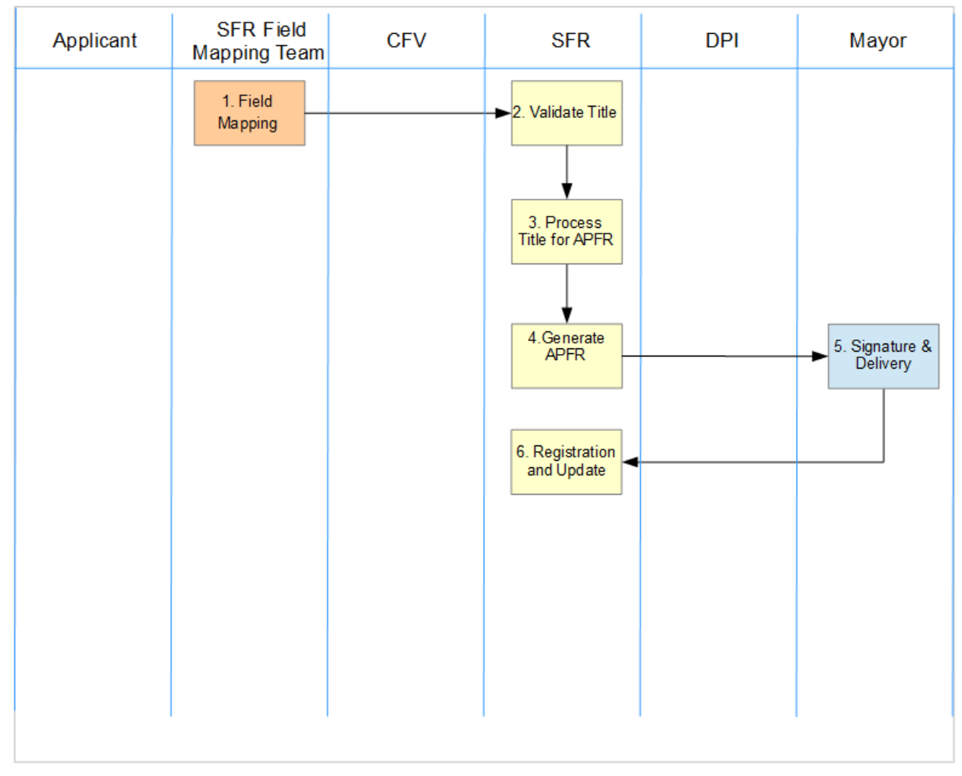This is a special workflow to capture existing titles – those lands that have either a:: 1- Arrêté d’attribution, 2- PV de constatation de Possession Foncière or a Autre document. As part of the process the Cadastral Department will provide a listing of all Titles that they have process in Boudry Commune.

| **#** | **Activity** | **Description/Business Context** | **System (Inputs & Outputs)** |
| --- | --- | --- | --- |
|  | Field Mapping (Pre-adjudication) | General Description CFV agent initiates process for the collection of land rights information. Confirms type of data capture – new or existing title. Based on selection of existing title, the MAST mobile application is used to capture spatial information. After spatial data capture, user captures a simplified set of attributes for existing title.   * **Title Number** * **Date of Registration** * **Title Type** 1- Arrêté d’attribution, 2- PV de constatation de Possession Foncière; or 3- Autre document * **Application Type:** individual or collective * **First name** * **Last name** * **Profession** * **Mobile telephone number**   Typical operations on this stage   * Confirms Data Capture Type to initiate data capture on mobile device. * Through discussions with occupant, and the walking of physical boundaries of the property, the CFV agent will capture parcel boundaries by capturing the coordinate corners of parcel boundaries. The spatial data is saved to mobile phone. * After capture of spatial unit, the attribute for selected data type will be opened and the CFV agent will fill in appropriate attribute forms. | Input Data   * Activation of data capture type (existing) * New GIS parcel boundary feature; * Spatial unit number will be automatically defined on phone to facilitate importation;   Output Data   * Collection of spatial data * Collection of attribute data * Data is flagged a existing title. |
|  | Validate Title | General Description  SFR users will review a listing of land records. For records that are existing land records, the SFR will review attributes, and look at listing of existing titles that has been provided to him by the Regional Cadastral Department. Once the Information has been verified, he/she will contact the person and request that they bring in an existing copy of the title to the SFR. Based on submittal and verification of information, the SFR will approve and move the transaction to “Process Title for APFR” Stage  Typical Operations on this stage   * Review listing of land records created by data that has been imported into system. * Select land record (imported data shown in DMI dashboard, each land record represents a transaction in the system) * Review information – spatial units and attributes; * Update spatial record (edit to parcel using standard GIS tools); * Approve and move the transaction to “Process Title for APFR” Stage | Input Data   * Spatial and tabular land record data captured in the field (transaction record).   Output Data   * Transaction record |
|  | Process Title for APFR | General Description  The SFR agent will initiate the process for generating an APFR, by selected the edit attribute action. This action will open a series of tabs that are available for reviewing and editing attributes. The SFR agent will input required attributes needed for the generation of an APFR  Typical Operations on this stage  Open land record  Enter attributes of land record  Update and approve attributes; and  Approve and move the transaction to the “Generate APFR” stage |  |
|  | Generate APFR | General Description  The SFR agent reviews approved listing PV forms that he/she has received from the CFV, then searches the MAST DMI and updates record as adjudicated. The SFR approves or adjudicates the MAST transaction information record.  The SFR agent will utilize the reporting tool to generate and print the APFR. Once the APFR is printed, the status of the transaction is changed to “final” and the copy of the APFR will be sent to the mayor’s office in duplicate.  Typical operations on this stage   * Search, review and retrieve land record – spatial and tabular * MAST transaction record * Select land record /transaction * Review land record information * Generate APFR * Approve and move transaction record to the “final registration stage” | Input Data   * CFV approved public notices (listing paper) * DPI approval? * MAST Land Record/Transaction Record   Output Data   * APFR * **Form 5. Fomulaire\_Attest\_Poss\_Fonc\_ individuelle initiale\_final\_KDG\_validé (Individual APFR)** * **Form 8: Formulaire Attest\_Poss\_Fon\_Rurale\_collective\_final\_KDG\_validé (Collective APFR)** |
|  | Signature | General Description  This process is outside of the system. The Mayor reviews and signs APFR (2 copies) and returns the executed documents to the SFR.  Typical operations on this stage  None – Not in System | Input Data   * APFR   Output Data   * Executed APFR |
|  | Registration and Delivery | The applicant, upon payment of the applicable fees, will present the SFR agent with a receipt. The SFR agent will search and review MAST transaction record, and update the record with receipt numbers and payment information, Once payment information is added to the record, and APFR is delivered, the MAST transaction record will be updated “Delivered”. The SFR will provide the applicant with an executed APFR. | Input Data   * Executed APFR * Receipt   Output Data   * None |

# Software Requirements

## Mobile Application

MAST shall provide the capability to create new property records and capture and store relevant information concerning transactions, ownership, rights and interests.

|  |  |  |
| --- | --- | --- |
| #. | Description | Details/Comments |
|  | The MAST Mobile Data Capture Application shall support the capture of alphanumeric information on spatial units (i.e. geographic features). |  |
|  | The MAST Mobile Data Capture Application shall allow the display relevant background spatial data, including vector and raster data. | Imagery  APFR  Title  Base Data Boundry/Sector/Roads |
|  | The MAST Mobile Data Capture Application shall support the review of information and verification of information on screen. |  |
|  | The MAST Mobile Data Capture Application shall notify the user when all of the mandatory information has been entered successfully. |  |
|  | The MAST Mobile Data Capture Application shall guide users through the use of dialogue boxes or notices |  |
|  | The MAST Mobile Data Capture Application shall guide users through the use of dialogue boxes or notices |  |
|  | The MAST Mobile Data Capture Application shall follow a workflow. | 1. Spatial Data 2. General Attribute 3. Property 4. Tenure 5. Person 6. Multimedia |
|  | The MAST Mobile Data Capture Application user Interface shall support the English and French Language. |  |

## DMI

### Land Record Dashboard

|  |  |  |
| --- | --- | --- |
| #. | Description | Details/Comments |
|  | MAST shall provide for the validation of data that is imported from data captured in the field. | Both spatial and attribute data shall be validated. |
|  | MAST shall provide a well-organized and web-based interface for the management of data captured in the field by mobile phones. |  |
|  | MAST shall support the review and edit of spatial information imported into the system. |  |
|  | MAST shall support the review and edit of tabular information imported into the system. |  |
|  | MAST shall support management of information and facilitate the automatic filling of data in template reports | See reporting |
|  | MAST shall support workflow management and allow users to visualize the stage and status of a transaction record | Workflow Stages Listed Here |
|  | MAST shall provide a standardized list of actions and tool sets for reviewing, editing and moving transactions through stages required for registration of APFRs. | Actions Listed Here |

### Land Records Management (Workflow)

|  |  |  |
| --- | --- | --- |
| #. | Description | Details/Comments |
|  | MAST shall provide workflow based business logic and be based on a set of defined business rules to facilitate movement between stages and decision making. | See Registration Work Process |
|  | MAST shall provide workflow to facilitate the administration of changes and/or revisions in the status of the transaction in stages to facilitate the tracing of applications through different stages. | For each workflow stage there will be: new, in progress, complete |
|  | MAST shall provide workflow to facilitate the movement of transaction record to different stages through the use of standardized dialog boxes | Dialog boxes will be customized to guide users actions for the approval or rejection of transaction records and their subsequent changes between stages. |
|  | MAST shall support the automatic generation of an application or transaction number for processed and accepted applications. | Transaction or Demand Number |
|  | MAST shall support the automatic generation of a series of identifiers in different stages of the workflow, and update of date and time of the required format (Year/Month/Day). | See Identifiers |
|  | MAST shall have the ability to integrate execution of internal and external processes within one workflow. | Some key work processes will be executed manually outside of MAST. |
|  | MAST shall provide the functionality for entering and storing explanations for rejections. |  |
|  | MAST will be configured to allow multiple user agencies the same graphic interface, however, tools sets and/or editing capabilities may be constrained based on business rules and rights. |  |

### Identifiers and Land Record Search Functionality

|  |  |  |
| --- | --- | --- |
| #. | Description | Details/Comments |
|  | MAST shall provide the ability to generate, manage and search for an application based on its application or transaction number. | Application Number or Demand Number |
|  | MAST shall provide the ability to generate and manage and search for the adjudication number or PV number, which is the number provided to the Form 7: PV de Constatation Contradictoire. | Form 7: PV de Constatation Contradictoire Number |
|  | MAST shall provide the ability to generate, manage and search for an APFR based on its number. | APFR Number – this is the number provided to an APFR |
|  | MAST shall provide the ability to generate, manage and search for registered transaction details based on its registration number. | Registration Number – this number is provided at the end of the process. |
|  | MAST shall provide the ability to generate, manage and search for a property by its parcel number. | Parcel number  Section – Lot – number  000-000-0000 |
|  | MAST shall provide the ability to generate, manage and search for a property by its USIN number. | Automatically generated by MAST |
|  | MAST shall provide the ability to search for a property by its applicant name. |  |

### Data Visualization (land record)

|  |  |  |
| --- | --- | --- |
| #. | Description | Details/Comments |
|  | MAST shall provide the visualization of parcel geometry and associated data in a separate tab in attribute edit and visualization dialog. | * Coordinates shall be shown in WGS 84, UTM Zone 30 N |
|  | MAST shall provide for the review and export coordinate geometry data | * Coordinates will need to be exported in CSV format for each land record from this screen. |
|  | MAST shall provide for the review data in standard report templates | * See reporting |

### Data Visualization (Mapping View)

|  |  |  |
| --- | --- | --- |
| #. | Description | Details/Comments |
|  | MAST shall provide visualization of multiple spatial layers:  Spatial Unit  Existing Titles  Existing APFR  Commune Boundary  Commune Base data  Commune Sections  Imagery | * Spatial Unit captured as part field mapping from mobile phone; * Existing APFRs (spatial layer = shapefile to be provided) * Existing Titles (spatial layer = shapefile to be provided) * Commune Base data (roads, village names, etc.) * Commune Sections * Imagery |
|  | MAST shall display basic attribute information in its DMI such as: | * Parcel Number * PV Number * APFR Number * Date of APFR * Name (first) * Name (last) * Gender * Type (individual or collective) * Area * Land Use |
|  | MAST shall provide access for all stakeholders to see the spatial unit maps and associated data. |  |
|  | MAST shall provide better access to tools sets by logically grouping tools by work process that is being performed. |  |
|  | MAST shall allow for thematic display functions by different attribute values | * i.e. date of acquisition, status, gender, or any other attribute value |
|  | MAST shall provide for the generation of standard map layout functions for data verification and visualization purposes | * Map Verification Purposes * Standard Map Layout for Presentation Purposes |

### Reporting

|  |  |  |
| --- | --- | --- |
| #. | Description | Details/Comments |
|  | MAST shall allow for the generation, visualization and printing of an application form(s). | * Form 1: Demande de constatation de possession foncière rurale à titre individuel ou collectif (Application form for individuals of collective) * Form 2: Formulaire de Mandat pr demande collective\_final\_KDG\_validé Mandate for collective application) |
|  | MAST shall allow for the generation, visualization and printing of a public notice. | * Form 3: Formulaire\_avis\_publicté foncière\_final\_KDG\_validé (Public Notice) |
|  | MAST shall allow for the generation, visualization and printing of the principle land record document used for adjudication. | * Form 7: PV de Constatation Contradictoire |
|  | MAST shall allow for the generation, visualization and printing of the payment request letter. This will be a form letter where values are entered and values are saved, however, there will be no calculations | * Payment Request Letter (TBD) |
|  | MAST shall allow for the generation, visualization and printing of the Property Boundary Map. | * Croquis de terrain * Plan de situation |
|  | MAST shall allow for the generation, visualization and printing of the APFR documents. | * Form 5. Fomulaire\_Attest\_Poss\_Fonc\_ individuelle initiale\_final\_KDG\_validé (Individual APFR) * Form 8: Formulaire Attest\_Poss\_Fon\_Rurale\_collective\_final\_KDG\_validé (Collective APFR) |
|  | MAST shall support the generation of statistical reports | **Map register**   * number of spatial units mapped, by tenure * number of spatial units mapped, by gender   **Application register**   * number of application processed, by tenure * number of application processed, by gender   **APFR register**   * number of APFR printed, by tenure * number of APFR printed, by gender |

|  |
| --- |
|  |

# Use Case

This section provides a high level overview of key business requirements of Mobile Technology Pilot Project for the capture of Land Rights Information.

* **Mobile Data Capture Application -** Mobile application to capture land rights information in field with following capabilities:
  + Capture Land Rights information (spatial, alphanumeric, and multimedia) on mobile devices
  + Capture personal, property and tenure information of spatial units
  + Transfer captured data to back-end server
* **Mobile Application Configuration Tool** – Web based back-end application to configure the mobile application with following capabilities.
  + Configure data entry forms of mobile application
  + Configure data that needs to be downloaded on the mobile devices for data collection work
  + Configure Functions that will be enabled on mobile application
* **Land Rights Data management Infrastructure application** – To ingest, manage and store data of land rights information collected via mobile devices with following functionalities:
  + Provide administration set-up, etc.
  + Tool to facilitate ingestion and validation of data into a RDBMS, that is configured on the STDM data model
  + Configuration of the database, including the addition of customized fields based on data model
  + Processing and organization of data according to predefined rules
  + Access permissions based access on data and functions
  + Facility to export data into variety of formats for use in external applications

## Mobile Data Capture Application

Proposed mobile application will be capable of capturing of spatial, attribute and multimedia data of spatial units in field.

Mobile application will provide a login page so that authenticated users can login into the application. User credentials (username and password) will be shared with CFV Agent using which they will login into the application.

### Use Case-MTP -01: Authentication

|  |  |
| --- | --- |
| **Use case** | User Authentication |
| **Brief Description** | This functionality will allow CFV Agent to login into mobile data capture application. |
| **Actors** | CFV Agent |
| **Preconditions** | User should be registered into the system. |
| **Trigger** | User starts the application by tapping application icon on mobile device. |
| **Main Flow** | 1. On invocation of application, login screen will appear. 2. On first time login, user enters User Name, Password and taps on Login Button. 3. Application authenticates the user from the server in case user logs in for the first time, otherwise authentication will be done from local profile saved on the device. 4. User name and password would be remembered by the application till the user logs out manually from the application. 5. User taps on Login button. 6. System authenticates user’s credentials. 7. Upon successful authentication user will be shown a dashboard containing following tabs:  * Map Viewer * Capture Data * Data Review * Download Data * Sync up Data * User Preferences * Logout |
| **Alternative Flows** | On unsuccessful login, application gives an error message to check username/password. |
| **Notes & Issues** |  |
|  |  |

**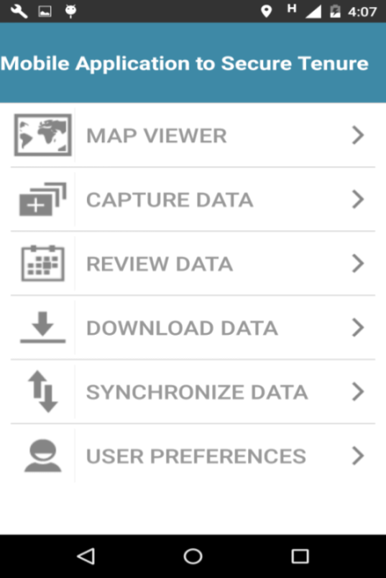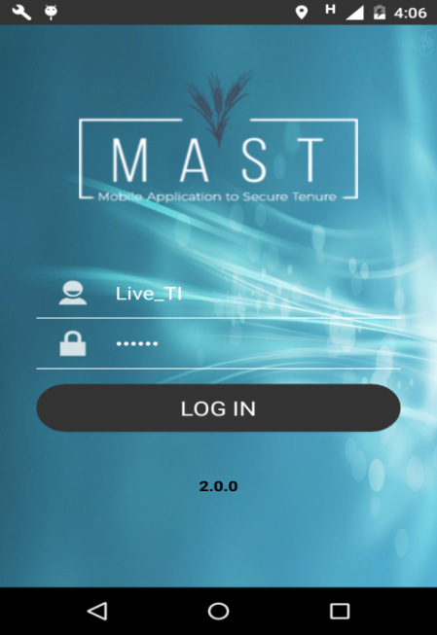Login & Dashboard page of Mobile Application-**

**Download Data**

Download Data feature will be provided in the mobile application to provide the facility to download configuration information and base data on the device on first login into the application. This is a one-time download activity which will be done on first login into the mobile application.

Once the survey project attribute configuration and base data is downloaded on device, data collection work can be initiated on the device in the field. Configuration information of attributes cannot be modified further. Configuration information will be downloaded on first login on the mobile device for data collection work.

### Use Case-MTP -02: Download Configuration Data

|  |  |
| --- | --- |
| **Use case** | Download Configuration Data |
| **Brief Description** | This functionality will provide the facility to download configuration information of project on first login into the application. |
| **Actors** | CFV Agent |
| **Preconditions** | User has successfully logged in. This functionality will only be available on connected mode i.e. user must be connected to remote database. |
| **Trigger** | User will login into the system and tap Download link. |
| **Main Flow** | 1. User will login into the system and select Download Configuration link. 2. Application will check the network connectivity status. In case of connectivity is not available, error messages will be displayed. 3. Post connectivity check, system download the configuration information of project allocated to the logged in user on the device. 4. System display a message ‘Data Downloaded’ post successful download of project configuration information to device. 5. System will display the attribute pages of data collection as per configuration of selected project. |
| **Alternative Flows** | NA |
| **Notes and Issues** | 1. NA |

### 

**Map Viewer**

MTP Mobile Data Capture application will provide a map viewer which will provide the spatial visualization of all the parcels (spatial units) collected in the field on the base data. It will also provide spatial data viewing tools.

Map viewer will provide the spatial units’ in view only mode with the Identify tool to view attributes of selected spatial unit. User can further invoke Capture New Data, Review or editing functions for field data collection and review work.

### Use Case-MTP -03: Map Viewer

|  |  |
| --- | --- |
| **Use case** | Map Viewer |
| **Brief Description** | This functionality will provide the map viewer feature of mobile application. Map Viewer will provide the facility to view data of spatial units on map. |
| **Actors** | CFV Agent |
| **Preconditions** | User has successfully logged in and downloaded data. |
| **Trigger** | User has clicked on ‘Map Viewer’ tab on landing page of mobile device. |
| **Main Flow** | * 1. User clicks on ‘Map Viewer’ tab on landing page.   2. By default, the map will be centred to the set up project coordinates.   3. Map Viewer will display spatial data of spatial units (parcels) collected on mobile device.   4. Map Viewer will provide a toolbar with following tools:  1. **GPS** – Take the user to GPS location of user 2. **Go To location** – User can use this tool to directly go to X, Y location. User can manually enter X, Y coordinates and will be then taken to specific location on map. 3. **Measure** – Measure tool to measure area of polygon 4. **Identify** – Identify tool to view attributes of selected spatial unit (in view only mode) 5. **Layer Control** – Layer Control to view the list of layers visible on map. 6. **Save Bookmark** – User can go to a particular location on map and save it as bookmark along with name of bookmark. (Maximum 8 bookmark locations can be saved by the user in the device) 7. **Go To Bookmark –** This tool will list all the saved bookmarks so that user can directly go to saved location on map.    1. Map Viewer will also display a toolbar on the bottom of the page to enable user to directly go to Capture Data and Review Data functions (these features will be available only to authorised users of data collection). |
| **Alternative Flows** | NA |
| **Notes and Issues** | * 1. Map viewer will also provide all the basic features to navigate into the map.  1. Zoom In - Enables the user to enlarge the map view. 2. Zoom Out - Enables the user to reduce the magnification level of the map view. 3. Pan – Enables the user to pan the map in that direction in which the touch screens is moved. |

### 

### Use Case-MTP -05: Capture Data

|  |  |
| --- | --- |
| **Use case** | Capture Spatial Data |
| **Brief Description** | This functionality will provide the functionality to initiate the process of capture new spatial data on map viewer of mobile application. |
| **Actors** | CFV Agent |
| **Preconditions** | User has successfully logged in and downloaded data. |
| **Trigger** | * 1. User can clicked on ‘Capture New Data’ tab on Mobile application landing page.   2. User has clicked on ‘Capture New Data’ tab on Summary page.   3. User has clicked on ‘Capture New Data’ tab on Map Viewer. |
| **Main Flow** | * 1. User clicks on ‘Capture New Data’ tab on Summary page.   2. System will display the map viewer with the base map of designated area allocated to user.   3. Map Viewer will provide a toolbar with following tools to capture/edit spatial units on map:   4. ***Capture New Data –*** Allows user to collect spatial, attribute and multimedia data of new spatial units   5. ***Edit Data –*** Allows user to edit spatial data of selected parcel   6. ***Delete –*** Allows user to delete data of parcel collected by the user (before sync-up of data is done)   7. ***Measure -*** Tool to calculate the length/area of a polygon.   8. ***Info –*** Allows user to view Information of selected parcel on map. |
| **Alternative Flows** | When a user selects a spatial unit from the Data listing page for review, application opens the Map viewer and display the spatial data on selected parcel on map:   1. User clicks on ‘Data Review‘on mobile application dashboard or Data Capture Landing Page. 2. System display list of spatial units collected by the user on device. 3. User selects a spatial unit and click on Edit Spatial Data to edit spatial data of selected unit on map. 4. System will open the Map viewer to view/edit the selected parcel on map. |
| **Notes and Issues** | 1. Map viewer will also provide all the basic features to navigate into the map. 2. Zoom In - Enables the user to enlarge the map view. 3. Zoom Out - Enables the user to reduce the magnification level of the map view. 4. Pan – Enables the user to pan the map in that direction in which the touch screens is moved. |

### Use Case-MTP -06: Spatial Data Capture Tools

|  |  |
| --- | --- |
| **Use case** | Spatial Data Capture Tools |
| **Brief Description** | This functionality will provide user to capture spatial data on map. These tools are draw polygon by manual drawing or capturing via GPS. |
| **Actors** | CFV Agent |
| **Preconditions** | User has successfully logged in and downloaded base data on device. |
| **Trigger** | User clicks on the ‘Capture New Data’ link on the map viewer. |
| **Main Flow** | * 1. User clicks on Capture New Data on map viewer.   2. System will display a list of tools to capture spatial data on map. (These tools will be configurable by user preferences option on the mobile device)      1. **Draw Polygon–**          + Draw polygon – Tool to manually draw polygon      2. **Capture polygon by GPS-**         + Tool to capture polygon by GPS of device   3. User selects the required tool and manually draws geometry.   4. User switches on GPS of the device and start moving in the direction to capture polygon and end at a point.   5. User clicks on ‘Save’ to save the geometry of spatial unit. Spatial data of parcel will be saved in local database of device.   6. User can navigate to capture attribute data after working on map by clicking on ‘Attribute Form’ button on top bar. |
| **Alternative Flows** | NA |
| **Notes and Issues** | Spatial unit created on the device will be stored on the mobile as a (.GeoJSON) file format with draft status. Draft status means that only the status of data is ‘Draft’ as it has to be yet finalized by the user. It will be persisted on the device in draft status also and will be accessible even after system crashes. |
| **Screen** | Screenshot_2016-09-12-16-29-22.png |

**Attribute Data Capture & Editing**

Mobile application will provide functionalities to capture attribute and multimedia data of spatial units.

Attribute data of spatial units is categorized into multiple categories. These are:

* General Information
* Property Information
* Tenure Information
* Person Information
* Multimedia Files
* Custom Attributes

Attributes that will be captured under these categories of data is configurable by mobile configuration tool. They may vary across multiple survey projects. Mandatory field checks will be implemented in the mobile data capture application so that valid data is submitted by the mobile application user in the field.

### Use Case-MTP -09: Capture Attribute Data

|  |  |
| --- | --- |
| **Use case** | Capture Attribute Data |
| **Brief Description** | This functionality will allow User to capture attribute data of spatial units. User will capture attributes for new spatial units and can directly view/edit attribute information of existing spatial units. |
| **Actors** | CFV Agent |
| **Preconditions** | User has successfully logged in and has captured spatial data. |
| **Trigger** | User will click on ‘Save’ icon on top bar (after draw polygon) of map viewer post creation of spatial data. |
| **Main Flow** | * 1. Once spatial unit has been captured, the User will click on ‘Save’ icon on top bar of map viewer post creation of spatial data.   2. Application opens general information window of spatial unit.   3. Multiple tabs underneath General information will be provided to capture land rights information in different categories:      + **Property Information:** Facility will be provided to add details of property along with its adjacent property information.      + **Tenure Information-** In ‘Add social tenure’ page, User selects ‘Type of tenure’ and tap on save button (screen 2).      + If user selects ‘Individual’ tenure type, User needs to add Person’s details (Form 1).      + If user selects ‘Collective’ tenure type, User needs to add Person’s details (Form 1) as well as ‘Person of interest’ details.      + If user selects ‘Existing’ tenure type, User needs to add Person’s details with minimal set of attributes.      + **Person Information:** User needs to add ‘Person’ and ‘Person of Interest’ as per the rule of tenure type (As given above).   4. Required validations will be applied on all mandatory fields before submission.   5. After validation, data will be saved in local database of device. |
| **Alternative Flows** | NA |
| **Notes and Issues** | NA |
| **Screen 1** | Screenshot_2016-09-12-16-07-53.png |
| **Screen 2** | Screenshot_2016-09-12-16-08-18.png |
| **Screen 3** | 8.png |
| **Screen 4** | 11.png |
| **Screen 5** | 9.png |

### Use Case-MTP -10: Capture Property Multimedia Information

|  |  |
| --- | --- |
| **Use case** | Capture Property Multimedia Information |
| **Brief Description** | This functionality will allow CFV Agent to capture multimedia information with a property. |
| **Actors** | CFV Agent |
| **Preconditions** | User has successfully logged in and has captured spatial data of spatial units. |
| **Trigger** | * 1. User will click on Multimedia tab on overall Spatial unit information page. |
| **Main Flow** | * 1. User clicked on Multimedia info tab of parcel.   2. User clicks on select button on multimedia window of parcel in tabbed view to select and upload multimedia file from the device.   3. User selects multimedia file and enter attributes associated with the multimedia file. These attributes can be name, date of upload, remarks.   4. Post capturing of multimedia file, it will be associated to the selected property.   5. User can capture multimedia files (photos, videos, testimony files) directly to the person information. (Max. size of images is 150 MB and length of video is 2 min. and size should be 3 MB)   6. Multimedia info: User can capture photos/videos and associate it with the spatial unit. User can associate one or more multimedia files |
| **Alternative Flows** | NA |
| **Notes and Issues** | NA |

### Use Case-MTP -11: View/Edit Multimedia Information

|  |  |
| --- | --- |
| **Use case** | View/Edit Multimedia Information |
| **Brief Description** | This functionality will allow users to view existing multimedia files associated with the property/person and edit attributes associated with it. User can also remove the multimedia file till the data has been marked as completed and synced. |
| **Actors** | CFV Agent |
| **Preconditions** | User has successfully logged in and has captured spatial data of spatial units. |
| **Trigger** | User will click on Multimedia tab of existing property.  User will click on Multimedia tab of person associated with a property. |
| **Main Flow** | * 1. User will click on Multimedia tab of existing property.   2. System display the multimedia tab with a number depicting number of multimedia files associated with the property.   3. User clicked on Multimedia info tab of parcel.   4. Associated multimedia file will be listed with following options:      + View – File name can be clicked to view associated multimedia file.      + Add new Multimedia file      + Attributes – To view/edit attributes associated with multimedia file      + Delete – To delete associated multimedia file |
| **Alternative Flows** | * 1. System display the multimedia tab with a number depicting number of multimedia files associated with the person.   2. User clicked on Multimedia info tab of person.   3. Associated multimedia file will be listed with following options:      + View – File name can be clicked to view associated multimedia file.      + Add new Multimedia file      + Attributes – To view/edit attributes associated with multimedia file      + Delete – To delete associated multimedia file |
| **Notes and Issues** | NA |

### Use Case-MTP -07: Edit Spatial Data

|  |  |
| --- | --- |
| **Use case** | Edit Spatial Data |
| **Brief Description** | This functionality will allow to Edit spatial data of captured spatial units. |
| **Actors** | CFV Agent |
| **Preconditions** | User has successfully logged in and has captured spatial data of spatial units. |
| **Trigger** | User select a spatial unit and click on Edit icon on the toolbar of map viewer or user select a spatial unit from Data Listing page and click on Edit Spatial data. |
| **Main Flow** | * 1. User selects a spatial unit on map viewer.   2. User clicks on Edit tool on the toolbar.   3. Spatial data of selected parcel is displayed in edit mode (vertex in highlighted mode).   4. User can edit a spatial unit by selecting and dragging the vertex to new location (polygon spatial units) or by moving the point spatial unit to a new location. |
| **Alternative Flows** | User selects a spatial unit from Data Listing page and click on Edit Spatial data. System will open the map viewer with selected spatial unit in editable mode to enable editing of spatial unit. |
| **Notes and Issues** | Basic editing features will be provided in the device for spatial data editing. |

### Use Case-MTP -08: Delete Data

|  |  |
| --- | --- |
| **Use case** | Delete Data |
| **Brief Description** | This functionality will allow Users to Delete captured spatial unit. Spatial data that has not been synced up to MTP backend data management application. Deletion process will delete all the data of selected spatial unit. |
| **Actors** | CFV Agent |
| **Preconditions** | User has successfully logged in and has captured spatial data. |
| **Trigger** | User selects a parcel and clicks on Delete tool on map viewer. |
| **Main Flow** | * 1. User selects a parcel on map viewer for deletion.   2. User clicks on delete tool.   3. System will show confirmation message to user.   4. User confirms option to delete selected record.   5. System will delete selected parcel from the device and shows confirmation message. |
| **Alternative Flows** | 1. User selects option not to delete. Application will remain in the same state. |
| **Notes and Issues** | NA |

### Use Case-MTP -04: Review Data

|  |  |
| --- | --- |
| **Use case** | Data Capture Landing Page |
| **Brief Description** | This functionality will provide the summary of data collected on mobile device |
| **Actors** | CFV Agent |
| **Preconditions** | User has successfully logged in. |
| **Trigger** | User has clicked on ‘Review Data’ tab on Mobile application dashboard. |
| **Main Flow** | * 1. User clicks on ‘ Review Data’ tab on dashboard.   2. System will display Summary page with given information sets:      + Number of records in draft mode (yet to be finalised by user)      + Number of records in completed mode (ready for sync up)      + Number of Sync up data(Sync up data)   3. User will be provided following options to review/edit the collected data in ‘draft mode’ section:      + ***Edit*** ***Spatial Data*** – This will open the property details in map viewer.      + ***Edit Attributes*** – This will directly open the land rights attribute information of selected property.      + ***Delete the complete record*** – This will delete the incorrectly entered record. Can be done only for draft records.      + ***Mark as Complete*** (ready for sync-up) – This will set the record as complete. All the completed records will be automatically synced up whenever connection is available or can be manually initiated for sync-up. |
| **Alternative Flows** | NA |
| **Notes and Issues** | NA |
| **Screen** | Screenshot_2016-09-12-16-07-37.png |

## WEB Application (DMI)

This functionality will allow the user to select the working Project for which land data management work is to be done. This is the first step in the land records management tool and thereafter all the data accessible in the land data management tool will be for the selected and authorized project.

### Use Case-MTP -12 SFR Role- Functionalities

|  |  |
| --- | --- |
| **Use case** | SFR Role |
| **Brief Description** | This functionality will allow user with this role to View, Edit, Approve/Reject and generate report in the application |
| **Actors** | SFR User |
| **Preconditions** | User has successfully logged in. |
| **Trigger** | User will click on Land Record TAB |
| **Main Flow** | 1. User click on ‘Land record’ tab. 2. User view following section in ‘Land Record’ tab  * Project name * Country name * Search option * Work flow summary * Land record display in table form  1. Display Search option with following fields-Parcel number, Application number, PV Number, Name etc. 2. User Search Land record according to searching option. 3. Display Workflow Summary section with following fields-   New-   * New * Validate & Generate Application * Process Application * Send for Opinion * Prepare for Adjudication * Publish * Generate APFR * Signature and Delivery * Register   Existing-   * New * Validate title * Process APFR * Generate APFR * Register  1. User display land record according to selected ‘Workflow’ from above options. 2. Land record display section in table with following fields-  * Application Number * PV Number * Name * Last name * Parcel Type * Application Type * Application Stage * Application status * Action  1. User click on Action Button in Land Record table. 2. After click on Action Button System display following actions-  * View map * View attribute * Edit Attribute * Print Map and Attribute * Approval * Reject * Generate MAP * View Parcel Number  1. If user clicks on ‘View map’ then system displays selected parcel on MAP and user can also edit the map. 2. If user clicks on ‘View Attribute’ then System display attribute for selected feature. 3. If user clicks on ‘Edit Attribute’ then System display attribute in editable mode for selected feature. 4. In case of Existing parcel, user can add the required details of attributes (as required in APFR form generation) in the ‘Edit Attribute’ section and in case of new parcel; user can edit the existing attributes. 5. In ‘View Attribute ’ and ’ Edit Attribute’ section if Attribute is Collective then in ‘Natural Person’ section it displays multiple person and ‘Person of Interest’ section. 6. In ‘View Attribute’ and ‘Edit Attribute’ section, click on ‘Map Coordinate’ tab then system display map image with (x, y) coordinates and also display Export button. 7. In “Map Coordinate” section, click on Export button then system exports (x and y) coordinates to CSV File (See image ‘Map coordinate’ below the table). 8. User clicks on ‘Generate Map’ action then system displays radio 2 buttons i.e., Boundary Map, Area Map and Land Record Forms. 9. User select Boundary map from above then system display selected parcel in Boundary map in which x, y coordinates and Neighboring parcels are displayed. (See image ‘Boundary Map’ below the table) 10. User select Area map from above then system display complete village area and highlights selected parcel. (See image ‘Standard map’ below the table) 11. User clicks on ‘Approval’ action then system display a popup in which comment box display with ‘Ok’ and ‘Cancel button’.(See ‘approve’ image below the table) 12. User click on Ok button then again display alert message “Do you want to approved selected parcel” with ok and cancel button .If user clicks on cancel button then approval action is cancel and popup is closed and in case user clicks on ok button then parcel is Approved(See ‘approve’ image below the table). 13. User click on ‘Reject’ action then system display a popup in which comment box display with ‘ok’ and ‘Cancel button’(See ‘Reject’ image below the table). 14. User click on Ok button then application again displays alert message “Do you want to reject selected parcel” with ok and cancel button .If user click on cancel button then Reject action is cancel and popup is closed and in case user clicks on Ok button then parcel is rejected(See ‘Reject’ image below the table). 15. User click on ‘print’ action then system generate a popup with following fields-  * Application form * Public notice * PV * Payment letter * APFR(Individual) * APFR(Collective) * Property boundary Map * Print button  1. User selects any option from above and takes printout but it depend on work flow summary. 2. If user click on ‘View Parcel Number’ action then System generate a popup window in which following fields are displayed:  * USIN * Parcel Number(which consists of Section, Lot, Number)  1. User Click on ‘Land Registry’ tab and see the land registry details with following fields  * Applicant Number * PV Number * APFR Number * Date of APFR * First name * Last name * Gender * Parcel type * Land use |
| **Alternative Flows** | 1. After approve the ‘Provide opinion’ by DPI, SFR generates PV Number with Form and Payment Request letter. 2. After ‘payment of fee’ by Applicant, SFR Generate the APFR number with form. |
| **Notes and Issues** | NA |
| **Screen 1** | reject.pngapprove alert.pngreject alert.pngapprove.png |
| **Screen 2 – SFR Dashboard** | SFR_Actions.jpg |
| **Screen 3** | User_SFR_WF.jpg |
| **Screen 4 – Map coordinates** | map_coordinates.png |
| **Screen 5 – Boundary Map** | print-template1.png |
| **Screen 6 –Standard Map** | print-template2.png |

### Use Case-MTP -12 DPI Role

|  |  |  |
| --- | --- | --- |
| **Use case** | DPI Role | |
| **Brief Description** | This functionality will allow to DPI to view, Approve/Reject in the application. | |
| **Actors** | DPI | |
| **Preconditions** | User has successfully logged in. | |
| **Trigger** | User will click on Land Record TAB | |
| **Main Flow** | 1. User click on ‘Land record’ TAB 2. Display Search option with following fields-Parcel number, Application number, PV Number etc. 3. User Search Land record according to searching option. 4. Land record display in table with following fields-  * Application Number * PV Number * Name * Last name * Parcel Type * Application Type * Application Stage * Application status * Action  1. User click on Action Button in Land Record table. 2. After click on Action Button System display following actions-  * View Map * View Attribute * Print Map and Attribute * Approval * Reject * Edit cadastral option  1. User clicks on ‘View map’ then system display selected parcel on MAP. 2. User click on ‘View’ then System display Attribute. 3. In “Map Coordinate” section, click on Export button then system export to CSV File for parcel. 4. User clicks on ‘Approval’ action then system display a popup in which Comment box display with ‘ok’ and ‘Cancel button’. 5. User clicks on the Ok button then again display alert message “do you want to Approved selected parcel” with Ok and cancel button. If user clicks on cancel button then approval action is cancelled and popup is closed. If click on Ok button then parcel is Approved. 6. User clicks on ‘Reject’ action then system again display a popup in which Comment box display with ‘Ok’ and ‘Cancel button’ 7. If user click on the Ok button then application again display alert message “Do you want to reject selected parcel” with Ok and cancel button. If user clicks on Ok button then parcel is reject. if user click on cancel button then Reject action is cancel and popup is closed 8. User Click on ‘Land Registry’ tab and see the land registry details with following fields  * Applicant Number * PV Number * APFR Number * Date of APFR * First name * Last name * Gender * Parcel type * Land use | |
| **Alternative Flows** | NA | |
| **Notes and Issues** | NA | |
| **Screen 1 – DPI dashboard** | User_DPI.jpg | |
|  | |

# Data Model

## Mobile Application

|  |  |  |  |  |  |  |  |  |  |  |  |  |  |  |  |  |
| --- | --- | --- | --- | --- | --- | --- | --- | --- | --- | --- | --- | --- | --- | --- | --- | --- |
|  |  | |  | |  | |  |  |  | |  |  |  |  |  |  |
| **Category** | **So. No.** | **Table** | | **Attribute** | |  | **Description** | |  |
| **General** | -- | Project | | Project Name | |  | Project Name | |  |
| -- | Project | | Spatial unit ID | |  | Spatial ID Unit. | |  |
| 14 | Project | | Region | | Yes | **** | | Project\_Region,Project\_Area |
| 15 | Project | | Province | | Yes | **** | | Project\_Region,Project\_Area |
| 16 | Project | | Commune | | No(Use as District) | **** | | Project\_Region,Project\_Area |
| -- | Project | | Commune Code | |  | **** | |  |
| 17 | Project | | Village | | Yes | **** | | Project\_Region,Project\_Area |
| -- | Project | | Village Number | |  |  | |  |
| -- | Project | | Name of President of CV | |  |  | |  |
| 44 | Project | | MayorName | |  |  | |  |
| Property | 28 | Parcel (Spatial unit) | | Existing Use | | Yes | Agriculture | | Spatial\_Unit |
|  | Pastoral | |  |
|  | Syliviculture | |  |
|  | Aquaculture | |  |
|  | Other | |  |
| 24 | Parcel (Spatial unit) | | Neighbour North | | Yes | **** | | Spatial\_Unit |
| 25 | Parcel (Spatial unit) | | Neighbour South | | Yes | **** | | Spatial\_Unit |
| 26 | Parcel (Spatial unit) | | Neighbour East | | Yes | **** | | Spatial\_Unit |
| 27 | Parcel (Spatial unit) | | Neighbour West | | Yes | **** | | Spatial\_Unit |
| Tenure | 34 | Parcel (Spatial unit) | | Location of issuance of the applicant | | No | **** | |  |
| 35 | Parcel (Spatial unit) | | Nature of Application | | No | **** | |  |
| 36 | Tenure | | Tenure Type (Individual/Collective) | | Yes | individual | |  |
|  | Collective | |  |
| 39 | Parcel (Spatial unit) | | No. Family Members(Household) | | Yes | 1,2,3,4,5….10 | | Spatial\_Unit |
| -- | Type of Right | | APFR | |  |  | |  |
| Person |  | individual | |  | |  |  | |  |
| 1 | person | | First Name | | Yes | **** | | Natural\_Person |
| 2 | person | | Last Name | | Yes | **** | | Natural\_Person |
| 3 | person | | Date of Birth | | No | **** | |  |
| 4 | person | | Profession | | Yes(Occupation) | **** | | Natural\_Person |
| 5 | person | | Address | | No | **** | |  |
| 6 | person | | Refrence of ID Card | | No | **** | |  |
| 7 | person | | Father Name | | No | **** | |  |
| 8 | person | | Mother Name | | No | **** | |  |
| 9 | person | | Marital Status | | Yes | **** | | Natural\_Person |
| 10 | person | | Nature of Powers of Applicant | | No | **** | |  |
| 11 | person | | ID Number | | No | **** | |  |
| 38 | Person | | Id Card Establishment date | | No | **** | |  |
| 12 | person | | Gender | | Yes | **** | | Natural\_Person |
| 13 | person | | Place of Birth | | No(Use as Citizenship) | **** | |  |
|  | If Collective, capture information for persons of interest | | | | | | | |
| 1 | person | | First Name | | Yes | **** | | Natural\_Person |
| 2 | person | | Last Name | | Yes | **** | | Natural\_Person |
| 3 | person | | Date of Birth | | No | **** | |  |
| 5 | person | | Address | | No | **** | |  |
| 6 | person | | Refrence of ID Card | | No | **** | |  |
| 38 | Person | | Id Card Establishment date | |  | **** | |  |
| 13 | person | | Place of Birth | | No(Use as Citizenship) | **** | |  |

## DMI- Data Management Infrastructure

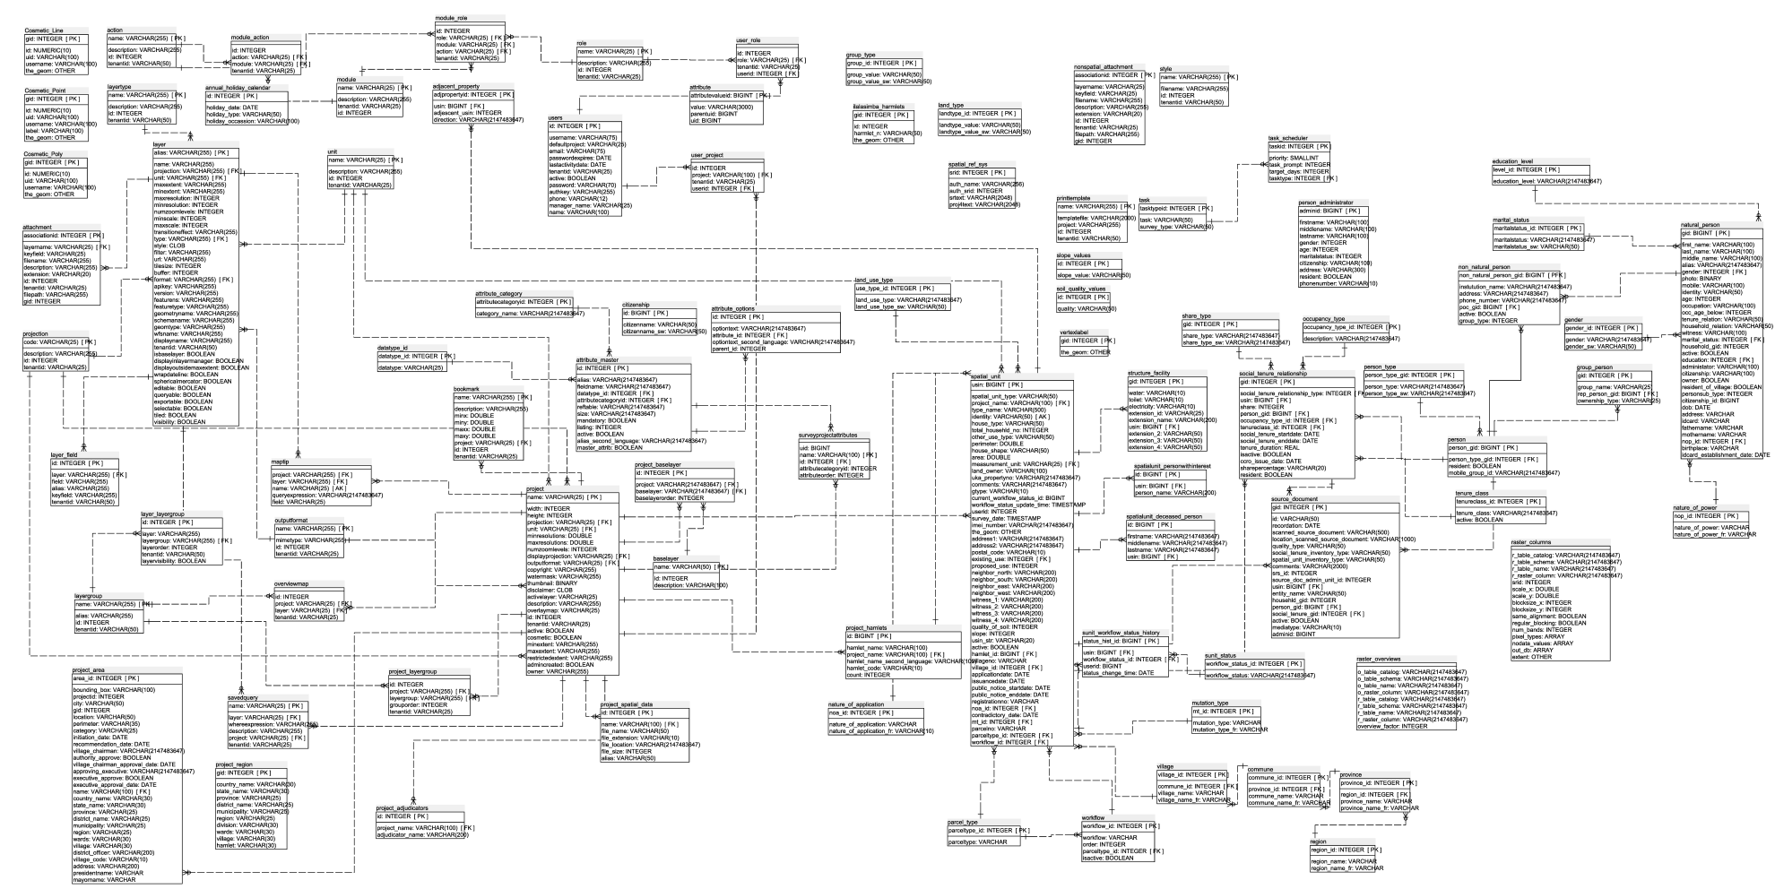

### action

|  |  |  |
| --- | --- | --- |
| **Logical Column Name** | **Physical Column Name** | **Type** |
| name (PK) | name | VARCHAR(255) |
| description | description | VARCHAR(255) |
| id | id | INTEGER |
| tenantid | tenantid | VARCHAR(50) |

Referenced By

* [module\_action](#module_action) referencing (name)
* [module\_role](#module_role) referencing (name)

### adjacent\_property

|  |  |  |
| --- | --- | --- |
| **Logical Column Name** | **Physical Column Name** | **Type** |
| adjpropertyid (PK) | adjpropertyid | INTEGER |
| usin  ([FK](#spatial_unit)) | usin | BIGINT |
| adjescent\_usin | adjescent\_usin | INTEGER |
| Direction | direction | VARCHAR(2147483647) |

References

* [spatial\_unit](#spatial_unit) through (usin)

### attribute

|  |  |  |
| --- | --- | --- |
| **Logical Column Name** | **Physical Column Name** | **Type** |
| attributevalueid (PK) | attributevalueid | BIGINT |
| value | value | VARCHAR(3000) |
| parentuid | parentuid | BIGINT |
| uid | uid | BIGINT |

### attribute\_category

|  |  |  |
| --- | --- | --- |
| **Logical Column Name** | **Physical Column Name** | **Type** |
| attributecategoryid (PK) | attributecategoryid | INTEGER |
| category\_name | category\_name | VARCHAR(2147483647) |

Referenced By

* [attribute\_master](#attribute_master) referencing (attributecategoryid)

### attribute\_master

|  |  |  |
| --- | --- | --- |
| **Logical Column Name** | **Physical Column Name** | **Type** |
| id (PK) | id | INTEGER |
| Alias | alias | VARCHAR(2147483647) |
| Fieldname | fieldname | VARCHAR(2147483647) |
| datatype\_id  ([FK](#datatype_id)) | datatype\_id | INTEGER |
| attributecategoryid  ([FK](#attribute_category)) | attributecategoryid | INTEGER |
| Reftable | reftable | VARCHAR(2147483647) |
| Size | size | VARCHAR(2147483647) |
| Mandatory | mandatory | BOOLEAN |
| Listing | listing | INTEGER |
| Active | active | BOOLEAN |
| alias\_second\_language | alias\_second\_language | VARCHAR(2147483647) |
| master\_attrib | master\_attrib | BOOLEAN |

References

* [attribute\_category](#attribute_category) through (attributecategoryid)
* [datatype\_id](#datatype_id) through (datatype\_id)

Referenced By

* [attribute\_options](#attribute_options) referencing (id)
* [surveyprojectattributes](#surveyprojectattributes) referencing (id)

### attribute\_options

|  |  |  |
| --- | --- | --- |
| **Logical Column Name** | **Physical Column Name** | **Type** |
| id (PK) | id | INTEGER |
| Optiontext | optiontext | VARCHAR(2147483647) |
| attribute\_id  ([FK](#attribute_master)) | attribute\_id | INTEGER |
| optiontext\_second\_language | optiontext\_second\_language | VARCHAR(2147483647) |
| parent\_id | parent\_id | INTEGER |

References

* [attribute\_master](#attribute_master) through (attribute\_id)

### baselayer

|  |  |  |
| --- | --- | --- |
| **Logical Column Name** | **Physical Column Name** | **Type** |
| name (PK) | name | VARCHAR(50) |
| id | id | INTEGER |
| description | description | VARCHAR(100) |

Referenced By

* [project\_baselayer](#project_baselayer) referencing (name)

### bookmark

|  |  |  |
| --- | --- | --- |
| **Logical Column Name** | **Physical Column Name** | **Type** |
| name (PK) | name | VARCHAR(255) |
| description | description | VARCHAR(255) |
| minx | minx | DOUBLE |
| miny | miny | DOUBLE |
| maxx | maxx | DOUBLE |
| maxy | maxy | DOUBLE |
| project  ([FK](#project)) | project | VARCHAR(25) |
| id | id | INTEGER |
| tenantid | tenantid | VARCHAR(25) |

References

* [project](#project) through (project)

### citizenship

|  |  |  |
| --- | --- | --- |
| **Logical Column Name** | **Physical Column Name** | **Type** |
| id (PK) | id | BIGINT |
| citizenname | citizenname | VARCHAR(50) |
| citizenname\_sw | citizenname\_sw | VARCHAR(50) |

### commune

|  |  |  |
| --- | --- | --- |
| **Logical Column Name** | **Physical Column Name** | **Type** |
| commune\_id (PK) | commune\_id | INTEGER |
| province\_id  ([FK](#province)) | province\_id | INTEGER |
| commune\_name | commune\_name | VARCHAR(0) |
| commune\_name\_fr | commune\_name\_fr | VARCHAR(0) |

References

* [province](#province) through (province\_id)

Referenced By

* [village](#village) referencing (commune\_id)

### Cosmetic\_Line

|  |  |  |
| --- | --- | --- |
| **Logical Column Name** | **Physical Column Name** | **Type** |
| gid (PK) | gid | INTEGER |
| id | id | NUMERIC(10,0) |
| uid | uid | VARCHAR(100) |
| username | username | VARCHAR(100) |
| the\_geom | the\_geom | Geometry |

### Cosmetic\_Point

|  |  |  |
| --- | --- | --- |
| **Logical Column Name** | **Physical Column Name** | **Type** |
| gid (PK) | gid | INTEGER |
| id | id | NUMERIC(10,0) |
| uid | uid | VARCHAR(100) |
| username | username | VARCHAR(100) |
| label | label | VARCHAR(100) |
| the\_geom | the\_geom | GEOMETRY |

### Cosmetic\_Poly

|  |  |  |
| --- | --- | --- |
| **Logical Column Name** | **Physical Column Name** | **Type** |
| gid (PK) | gid | INTEGER |
| id | id | NUMERIC(10,0) |
| uid | uid | VARCHAR(100) |
| username | username | VARCHAR(100) |
| the\_geom | the\_geom | GEOMETRY |

### datatype\_id

|  |  |  |
| --- | --- | --- |
| **Logical Column Name** | **Physical Column Name** | **Type** |
| datatype\_id (PK) | datatype\_id | INTEGER |
| datatype | datatype | VARCHAR(25) |

Referenced By

* [attribute\_master](#attribute_master) referencing (datatype\_id)

### education\_level

|  |  |  |
| --- | --- | --- |
| **Logical Column Name** | **Physical Column Name** | **Type** |
| level\_id (PK) | level\_id | INTEGER |
| education\_level | education\_level | VARCHAR(2147483647) |

Referenced By

* [natural\_person](#natural_person) referencing (level\_id)

### gender

|  |  |  |
| --- | --- | --- |
| **Logical Column Name** | **Physical Column Name** | **Type** |
| gender\_id (PK) | gender\_id | INTEGER |
| gender | gender | VARCHAR(2147483647) |
| gender\_sw | gender\_sw | VARCHAR(50) |

Referenced By

* [natural\_person](#natural_person) referencing (gender\_id)

### group\_person

|  |  |  |
| --- | --- | --- |
| **Logical Column Name** | **Physical Column Name** | **Type** |
| gid (PK) | gid | INTEGER |
| group\_name | group\_name | VARCHAR(25) |
| rep\_person\_gid  ([FK](#person)) | rep\_person\_gid | BIGINT |
| ownership\_type | ownership\_type | VARCHAR(25) |

References

* [person](#person) through (rep\_person\_gid)

### group\_type

|  |  |  |
| --- | --- | --- |
| **Logical Column Name** | **Physical Column Name** | **Type** |
| group\_id (PK) | group\_id | INTEGER |
| group\_value | group\_value | VARCHAR(50) |
| group\_value\_sw | group\_value\_sw | VARCHAR(50) |

### land\_type

|  |  |  |
| --- | --- | --- |
| **Logical Column Name** | **Physical Column Name** | **Type** |
| landtype\_id (PK) | landtype\_id | INTEGER |
| landtype\_value | landtype\_value | VARCHAR(50) |
| landtype\_value\_sw | landtype\_value\_sw | VARCHAR(50) |

### land\_use\_type

|  |  |  |
| --- | --- | --- |
| **Logical Column Name** | **Physical Column Name** | **Type** |
| use\_type\_id (PK) | use\_type\_id | INTEGER |
| land\_use\_type | land\_use\_type | VARCHAR(2147483647) |
| land\_use\_type\_sw | land\_use\_type\_sw | VARCHAR(50) |

Referenced By

* [spatial\_unit](#spatial_unit) referencing (use\_type\_id)

### layer

|  |  |  |
| --- | --- | --- |
| **Logical Column Name** | **Physical Column Name** | **Type** |
| alias (PK) | alias | VARCHAR(255) |
| name | name | VARCHAR(255) |
| projection  ([FK](#projection)) | projection | VARCHAR(255) |
| unit  ([FK](#unit)) | unit | VARCHAR(255) |
| maxextent | maxextent | VARCHAR(255) |
| minextent | minextent | VARCHAR(255) |
| maxresolution | maxresolution | INTEGER |
| minresolution | minresolution | INTEGER |
| numzoomlevels | numzoomlevels | INTEGER |
| minscale | minscale | INTEGER |
| maxscale | maxscale | INTEGER |
| transitioneffect | transitioneffect | VARCHAR(255) |
| type  ([FK](#layertype)) | type | VARCHAR(255) |
| style | style | CLOB |
| filter | filter | VARCHAR(255) |
| url | url | VARCHAR(255) |
| tilesize | tilesize | INTEGER |
| buffer | buffer | INTEGER |
| format  ([FK](#outputformat)) | format | VARCHAR(255) |
| apikey | apikey | VARCHAR(255) |
| version | version | VARCHAR(255) |
| featurens | featurens | VARCHAR(255) |
| featuretype | featuretype | VARCHAR(255) |
| geometryname | geometryname | VARCHAR(255) |
| schemaname | schemaname | VARCHAR(255) |
| geomtype | geomtype | VARCHAR(255) |
| wfsname | wfsname | VARCHAR(255) |
| displayname | displayname | VARCHAR(255) |
| tenantid | tenantid | VARCHAR(50) |
| isbaselayer | isbaselayer | BOOLEAN |
| displayinlayermanager | displayinlayermanager | BOOLEAN |
| displayoutsidemaxextent | displayoutsidemaxextent | BOOLEAN |
| wrapdateline | wrapdateline | BOOLEAN |
| sphericalmercator | sphericalmercator | BOOLEAN |
| editable | editable | BOOLEAN |
| queryable | queryable | BOOLEAN |
| exportable | exportable | BOOLEAN |
| selectable | selectable | BOOLEAN |
| tiled | tiled | BOOLEAN |
| visibility | visibility | BOOLEAN |

References

* [layertype](#layertype) through (type)
* [outputformat](#outputformat) through (format)
* [projection](#projection) through (projection)
* [unit](#unit) through (unit)

Referenced By

* [attachment](#attachment) referencing (alias)
* [layer\_field](#layer_field) referencing (alias)
* [maptip](#maptip) referencing (alias)
* [savedquery](#savedquery) referencing (alias)

### layer\_field

|  |  |  |
| --- | --- | --- |
| **Logical Column Name** | **Physical Column Name** | **Type** |
| id (PK) | id | INTEGER |
| layer  ([FK](#layer)) | layer | VARCHAR(255) |
| field | field | VARCHAR(255) |
| alias | alias | VARCHAR(255) |
| keyfield | keyfield | VARCHAR(255) |
| tenantid | tenantid | VARCHAR(50) |

References

* [layer](#layer) through (layer)

### layer\_layergroup

|  |  |  |
| --- | --- | --- |
| **Logical Column Name** | **Physical Column Name** | **dType** |
| id (PK) | id | INTEGER |
| layer | layer | VARCHAR(255) |
| layergroup  ([FK](#layergroup)) | layergroup | VARCHAR(255) |
| layerorder | layerorder | INTEGER |
| tenantid | tenantid | VARCHAR(50) |
| layervisibility | layervisibility | BOOLEAN |

References

* [layergroup](#layergroup) through (layergroup)

### layergroup

|  |  |  |
| --- | --- | --- |
| **Logical Column Name** | **Physical Column Name** | **Type** |
| name (PK) | name | VARCHAR(255) |
| alias | alias | VARCHAR(255) |
| id | id | INTEGER |
| tenantid | tenantid | VARCHAR(50) |

Referenced By

* [layer\_layergroup](#layer_layergroup) referencing (name)
* [overviewmap](#overviewmap) referencing (name)
* [project\_layergroup](#project_layergroup) referencing (name)

### layertype

|  |  |  |
| --- | --- | --- |
| **Logical Column Name** | **Physical Column Name** | **Type** |
| name (PK) | name | VARCHAR(255) |
| description | description | VARCHAR(255) |
| id | id | INTEGER |
| tenantid | tenantid | VARCHAR(50) |

Referenced By

* [layer](#layer) referencing (name)

### maptip

|  |  |  |
| --- | --- | --- |
| **Logical Column Name** | **Physical Column Name** | **Type** |
| project  ([FK](#project)) | project | VARCHAR(255) |
| layer  ([FK](#layer)) | layer | VARCHAR(255) |
| name | name | VARCHAR(25) |
| queryexpression | queryexpression | VARCHAR(2147483647) |
| field | field | VARCHAR(25) |

References

* [layer](#layer) through (layer)
* [project](#project) through (project)

### marital\_status

|  |  |  |
| --- | --- | --- |
| **Logical Column Name** | **Physical Column Name** | **dType** |
| maritalstatus\_id (PK) | maritalstatus\_id | INTEGER |
| maritalstatus | maritalstatus | VARCHAR(2147483647) |
| maritalstatus\_sw | maritalstatus\_sw | VARCHAR(50) |

Referenced By

* [natural\_person](#natural_person) referencing (maritalstatus\_id)

### module

|  |  |  |
| --- | --- | --- |
| **Logical Column Name** | **Physical Column Name** | **Type** |
| name (PK) | name | VARCHAR(25) |
| description | description | VARCHAR(255) |
| tenantid | tenantid | VARCHAR(25) |
| id | id | INTEGER |

Referenced By

* [module\_action](#module_action) referencing (name)
* [module\_role](#module_role) referencing (name)

### module\_action

|  |  |  |
| --- | --- | --- |
| **Logical Column Name** | **Physical Column Name** | **Type** |
| id | id | INTEGER |
| action  ([FK](#action)) | action | VARCHAR(25) |
| module  ([FK](#module)) | module | VARCHAR(25) |
| tenantid | tenantid | VARCHAR(25) |

References

* [action](#action) through (action)
* [module](#module) through (module)

### module\_role

|  |  |  |
| --- | --- | --- |
| **Logical Column Name** | **Physical Column Name** | **Type** |
| id | id | INTEGER |
| role  ([FK](#role)) | role | VARCHAR(25) |
| module  ([FK](#module)) | module | VARCHAR(25) |
| action  ([FK](#action)) | action | VARCHAR(25) |
| tenantid | tenantid | VARCHAR(25) |

References

* [action](#action) through (action)
* [module](#module) through (module)
* [role](#role) through (role)

### mutation\_type

|  |  |  |
| --- | --- | --- |
| **Logical Column Name** | **Physical Column Name** | **dType** |
| mt\_id (PK) | mt\_id | INTEGER |
| mutation\_type | mutation\_type | VARCHAR(0) |
| mutation\_type\_fr | mutation\_type\_fr | VARCHAR(0) |

Referenced By

* [spatial\_unit](#spatial_unit) referencing (mt\_id)

### natural\_person

|  |  |  |
| --- | --- | --- |
| **Logical Column Name** | **Physical Column Name** | **Type** |
| gid (PK) | gid | BIGINT |
| first\_name | first\_name | VARCHAR(100) |
| last\_name | last\_name | VARCHAR(100) |
| middle\_name | middle\_name | VARCHAR(100) |
| alias | alias | VARCHAR(2147483647) |
| gender  ([FK](#gender)) | gender | INTEGER |
| photo | photo | [-2] |
| mobile | mobile | VARCHAR(100) |
| identity | identity | VARCHAR(50) |
| age | age | INTEGER |
| occupation | occupation | VARCHAR(100) |
| occ\_age\_below | occ\_age\_below | INTEGER |
| tenure\_relation | tenure\_relation | VARCHAR(50) |
| household\_relation | household\_relation | VARCHAR(50) |
| witness | witness | VARCHAR(100) |
| marital\_status  ([FK](#marital_status)) | marital\_status | INTEGER |
| household\_gid | household\_gid | INTEGER |
| active | active | BOOLEAN |
| education  ([FK](#education_level)) | education | INTEGER |
| administator | administator | VARCHAR(100) |
| citizenship | citizenship | VARCHAR(100) |
| owner | owner | BOOLEAN |
| resident\_of\_village | resident\_of\_village | BOOLEAN |
| personsub\_type | personsub\_type | INTEGER |
| citizenship\_id | citizenship\_id | BIGINT |
| dob | dob | DATE |
| address | address | VARCHAR(0) |
| idcard | idcard | VARCHAR(0) |
| fathername | fathername | VARCHAR(0) |
| mothername | mothername | VARCHAR(0) |
| nop\_id  ([FK](#nature_of_power)) | nop\_id | INTEGER |
| birthplace | birthplace | VARCHAR(0) |
| idcard\_establishment\_date | idcard\_establishment\_date | DATE |

References

* [education\_level](#education_level) through (education)
* [gender](#gender) through (gender)
* [marital\_status](#marital_status) through (marital\_status)
* [nature\_of\_power](#nature_of_power) through (nop\_id)

Referenced By

* [non\_natural\_person](#non_natural_person) referencing (gid)

### nature\_of\_application

|  |  |  |
| --- | --- | --- |
| **Logical Column Name** | **Physical Column Name** | **dType** |
| noa\_id (PK) | noa\_id | INTEGER |
| nature\_of\_application | nature\_of\_application | VARCHAR(0) |
| nature\_of\_application\_fr | nature\_of\_application\_fr | VARCHAR(10) |

Referenced By

* [spatial\_unit](#spatial_unit) referencing (noa\_id)

### nature\_of\_power

|  |  |  |
| --- | --- | --- |
| **Logical Column Name** | **Physical Column Name** | **dType** |
| nop\_id (PK) | nop\_id | INTEGER |
| nature\_of\_power | nature\_of\_power | VARCHAR(0) |
| nature\_of\_power\_fr | nature\_of\_power\_fr | VARCHAR(0) |

Referenced By

* [natural\_person](#natural_person) referencing (nop\_id)

### non\_natural\_person

|  |  |  |
| --- | --- | --- |
| **Logical Column Name** | **Physical Column Name** | **dType** |
| non\_natural\_person\_gid (PK)  ([FK](#person)) | non\_natural\_person\_gid | BIGINT |
| instutution\_name | instutution\_name | VARCHAR(2147483647) |
| address | address | VARCHAR(2147483647) |
| phone\_number | phone\_number | VARCHAR(2147483647) |
| poc\_gid  ([FK](#natural_person)) | poc\_gid | BIGINT |
| active | active | BOOLEAN |
| group\_type | group\_type | INTEGER |

References

* [natural\_person](#natural_person) through (poc\_gid)
* [person](#person) through (non\_natural\_person\_gid)

### nonspatial\_attachment

|  |  |  |
| --- | --- | --- |
| **Logical Column Name** | **Physical Column Name** | **Type** |
| associationid (PK) | associationid | INTEGER |
| layername | layername | VARCHAR(25) |
| keyfield | keyfield | VARCHAR(25) |
| filename | filename | VARCHAR(255) |
| description | description | VARCHAR(255) |
| extension | extension | VARCHAR(20) |
| id | id | INTEGER |
| tenantid | tenantid | VARCHAR(25) |
| filepath | filepath | VARCHAR(255) |
| gid | gid | INTEGER |

### occupancy\_type

|  |  |  |
| --- | --- | --- |
| **Logical Column Name** | **Physical Column Name** | **Type** |
| occupancy\_type\_id (PK) | occupancy\_type\_id | INTEGER |
| description | description | VARCHAR(2147483647) |

Referenced By

* [social\_tenure\_relationship](#social_tenure_relationship) referencing (occupancy\_type\_id)

### outputformat

|  |  |  |
| --- | --- | --- |
| **Logical Column Name** | **Physical Column Name** | **Type** |
| name (PK) | name | VARCHAR(255) |
| mimetype | mimetype | VARCHAR(255) |
| id | id | INTEGER |
| tenantid | tenantid | VARCHAR(25) |

Referenced By

* [layer](#layer) referencing (name)
* [project](#project) referencing (name)

### overviewmap

|  |  |  |
| --- | --- | --- |
| **Logical Column Name** | **Physical Column Name** | **Type** |
| id | id | INTEGER |
| project  ([FK](#project)) | project | VARCHAR(25) |
| layer  ([FK](#layergroup)) | layer | VARCHAR(25) |
| tenantid | tenantid | VARCHAR(25) |

References

* [layergroup](#layergroup) through (layer)
* [project](#project) through (project)

### parcel\_type

|  |  |  |
| --- | --- | --- |
| **Logical Column Name** | **Physical Column Name** | **Type** |
| parceltype\_id (PK) | parceltype\_id | INTEGER |
| parceltype | parceltype | VARCHAR(0) |

Referenced By

* [spatial\_unit](#spatial_unit) referencing (parceltype\_id)
* [workflow](#workflow) referencing (parceltype\_id)

### person

|  |  |  |
| --- | --- | --- |
| **Logical Column Name** | **Physical Column Name** | **dType** |
| person\_gid (PK) | person\_gid | BIGINT |
| person\_type\_gid  ([FK](#person_type)) | person\_type\_gid | INTEGER |
| resident | resident | BOOLEAN |
| mobile\_group\_id | mobile\_group\_id | VARCHAR(2147483647) |

References

* [person\_type](#person_type) through (person\_type\_gid)

Referenced By

* [group\_person](#group_person) referencing (person\_gid)
* [non\_natural\_person](#non_natural_person) referencing (person\_gid)
* [social\_tenure\_relationship](#social_tenure_relationship) referencing (person\_gid)
* [source\_document](#source_document) referencing (person\_gid)

### person\_administrator

|  |  |  |
| --- | --- | --- |
| **Logical Column Name** | **Physical Column Name** | **Type** |
| adminid (PK) | adminid | BIGINT |
| firstname | firstname | VARCHAR(100) |
| middlename | middlename | VARCHAR(100) |
| lastname | lastname | VARCHAR(100) |
| gender | gender | INTEGER |
| age | age | INTEGER |
| maritalstatus | maritalstatus | INTEGER |
| citizenship | citizenship | VARCHAR(100) |
| address | address | VARCHAR(300) |
| resident | resident | BOOLEAN |
| phonenumber | phonenumber | VARCHAR(10) |

### person\_type

|  |  |  |
| --- | --- | --- |
| **Logical Column Name** | **Physical Column Name** | **Type** |
| person\_type\_gid (PK) | person\_type\_gid | INTEGER |
| person\_type | person\_type | VARCHAR(2147483647) |
| person\_type\_sw | person\_type\_sw | VARCHAR(2147483647) |

Referenced By

* [person](#person) referencing (person\_type\_gid)

### printtemplate

|  |  |  |
| --- | --- | --- |
| **Logical Column Name** | **Physical Column Name** | **Type** |
| name (PK) | name | VARCHAR(255) |
| templatefile | templatefile | VARCHAR(2000) |
| project | project | VARCHAR(255) |
| id | id | INTEGER |
| tenantid | tenantid | VARCHAR(50) |

### project

|  |  |  |
| --- | --- | --- |
| **Logical Column Name** | **Physical Column Name** | **Type** |
| name (PK) | name | VARCHAR(25) |
| width | width | INTEGER |
| height | height | INTEGER |
| projection  ([FK](#projection)) | projection | VARCHAR(25) |
| unit  ([FK](#unit)) | unit | VARCHAR(25) |
| minresolutions | minresolutions | DOUBLE |
| maxresolutions | maxresolutions | DOUBLE |
| numzoomlevels | numzoomlevels | INTEGER |
| displayprojection  ([FK](#projection)) | displayprojection | VARCHAR(25) |
| outputformat  ([FK](#outputformat)) | outputformat | VARCHAR(25) |
| copyright | copyright | VARCHAR(255) |
| watermask | watermask | VARCHAR(255) |
| thumbnail | thumbnail | [-2] |
| disclaimer | disclaimer | CLOB |
| activelayer | activelayer | VARCHAR(25) |
| description | description | VARCHAR(255) |
| overlaymap | overlaymap | VARCHAR(25) |
| id | id | INTEGER |
| tenantid | tenantid | VARCHAR(25) |
| active | active | BOOLEAN |
| cosmetic | cosmetic | BOOLEAN |
| minextent | minextent | VARCHAR(255) |
| maxextent | maxextent | VARCHAR(255) |
| restrictedextent | restrictedextent | VARCHAR(255) |
| admincreated | admincreated | BOOLEAN |
| owner | owner | VARCHAR(255) |

References

* [outputformat](#outputformat) through (outputformat)
* [projection](#projection) through (projection)
* [projection](#projection) through (displayprojection)
* [unit](#unit) through (unit)

Referenced By

* [bookmark](#bookmark) referencing (name)
* [maptip](#maptip) referencing (name)
* [overviewmap](#overviewmap) referencing (name)
* [project\_adjudicators](#project_adjudicators) referencing (name)
* [project\_area](#project_area) referencing (name)
* [project\_baselayer](#project_baselayer) referencing (name)
* [project\_hamlets](#project_hamlets) referencing (name)
* [project\_layergroup](#project_layergroup) referencing (name)
* [project\_spatial\_data](#project_spatial_data) referencing (name)
* [savedquery](#savedquery) referencing (name)
* [spatial\_unit](#spatial_unit) referencing (name)
* [surveyprojectattributes](#surveyprojectattributes) referencing (name)
* [user\_project](#user_project) referencing (name)

### project\_adjudicators

|  |  |  |
| --- | --- | --- |
| **Logical Column Name** | **Physical Column Name** | **Type** |
| id (PK) | id | INTEGER |
| project\_name  ([FK](#project)) | project\_name | VARCHAR(100) |
| adjudicator\_name | adjudicator\_name | VARCHAR(200) |

References

* [project](#project) through (project\_name)

### project\_area

|  |  |  |
| --- | --- | --- |
| **Logical Column Name** | **Physical Column Name** | **Type** |
| area\_id (PK) | area\_id | INTEGER |
| bounding\_box | bounding\_box | VARCHAR(100) |
| projectid | projectid | INTEGER |
| city | city | VARCHAR(50) |
| gid | gid | INTEGER |
| location | location | VARCHAR(50) |
| perimeter | perimeter | VARCHAR(35) |
| category | category | VARCHAR(25) |
| initiation\_date | initiation\_date | DATE |
| recommendation\_date | recommendation\_date | DATE |
| village\_chairman | village\_chairman | VARCHAR(2147483647) |
| authority\_approve | authority\_approve | BOOLEAN |
| village\_chairman\_approval\_date | village\_chairman\_approval\_date | DATE |
| approving\_executive | approving\_executive | VARCHAR(2147483647) |
| executive\_approve | executive\_approve | BOOLEAN |
| executive\_approval\_date | executive\_approval\_date | DATE |
| name  ([FK](#project)) | name | VARCHAR(100) |
| country\_name | country\_name | VARCHAR(30) |
| state\_name | state\_name | VARCHAR(30) |
| province | province | VARCHAR(25) |
| district\_name | district\_name | VARCHAR(25) |
| municipality | municipality | VARCHAR(25) |
| region | region | VARCHAR(25) |
| wards | wards | VARCHAR(30) |
| village | village | VARCHAR(30) |
| district\_officer | district\_officer | VARCHAR(200) |
| village\_code | village\_code | VARCHAR(10) |
| address | address | VARCHAR(200) |
| presidentname | presidentname | VARCHAR(0) |
| mayorname | mayorname | VARCHAR(0) |

References

* [project](#project) through (name)

### project\_baselayer

|  |  |  |
| --- | --- | --- |
| **Logical Column Name** | **Physical Column Name** | **Type** |
| id (PK) | id | INTEGER |
| project  ([FK](#project)) | project | VARCHAR(2147483647) |
| baselayer  ([FK](#baselayer)) | baselayer | VARCHAR(2147483647) |
| baselayerorder | baselayerorder | INTEGER |

References

* [baselayer](#baselayer) through (baselayer)
* [project](#project) through (project)

### project\_hamlets

|  |  |  |
| --- | --- | --- |
| **Logical Column Name** | **Physical Column Name** | **Type** |
| id (PK) | id | BIGINT |
| hamlet\_name | hamlet\_name | VARCHAR(100) |
| project\_name  ([FK](#project)) | project\_name | VARCHAR(100) |
| hamlet\_name\_second\_language | hamlet\_name\_second\_language | VARCHAR(100) |
| hamlet\_code | hamlet\_code | VARCHAR(10) |
| count | count | INTEGER |

References

* [project](#project) through (project\_name)

Referenced By

* [spatial\_unit](#spatial_unit) referencing (id)

### project\_layergroup

|  |  |  |
| --- | --- | --- |
| **Logical Column Name** | **Physical Column Name** | **Type** |
| id | id | INTEGER |
| project  ([FK](#project)) | project | VARCHAR(255) |
| layergroup  ([FK](#layergroup)) | layergroup | VARCHAR(255) |
| grouporder | grouporder | INTEGER |
| tenantid | tenantid | VARCHAR(25) |

References

* [layergroup](#layergroup) through (layergroup)
* [project](#project) through (project)

### project\_region

|  |  |  |  |  |
| --- | --- | --- | --- | --- |
| **Logical Column Name** | **Physical Column Name** | **Type** | **PK** | **Nullable** |
| gid (PK) | gid | INTEGER |
| country\_name | country\_name | VARCHAR(30) |
| state\_name | state\_name | VARCHAR(30) |
| province | province | VARCHAR(25) |
| district\_name | district\_name | VARCHAR(25) |
| municipality | municipality | VARCHAR(25) |
| region | region | VARCHAR(25) |
| division | division | VARCHAR(30) |
| wards | wards | VARCHAR(30) |
| village | village | VARCHAR(30) |
| hamlet | hamlet | VARCHAR(30) |

### project\_spatial\_data

|  |  |  |
| --- | --- | --- |
| **Logical Column Name** | **Physical Column Name** | **Type** |
| id (PK) | id | INTEGER |
| name  ([FK](#project)) | name | VARCHAR(100) |
| file\_name | file\_name | VARCHAR(50) |
| file\_extension | file\_extension | VARCHAR(10) |
| file\_location | file\_location | VARCHAR(2147483647) |
| file\_size | file\_size | INTEGER |
| alias | alias | VARCHAR(50) |

References

* [project](#project) through (name)

### projection

|  |  |  |
| --- | --- | --- |
| **Logical Column Name** | **Physical Column Name** | **Type** |
| code (PK) | code | VARCHAR(25) |
| description | description | VARCHAR(255) |
| id | id | INTEGER |
| tenantid | tenantid | VARCHAR(25) |

Referenced By

* [layer](#layer) referencing (code)
* [project](#project) referencing (code)
* [project](#project) referencing (code)

### province

|  |  |  |
| --- | --- | --- |
| **Logical Column Name** | **Physical Column Name** | **Type** |
| province\_id (PK) | province\_id | INTEGER |
| region\_id  ([FK](#region)) | region\_id | INTEGER |
| province\_name | province\_name | VARCHAR(0) |
| province\_name\_fr | province\_name\_fr | VARCHAR(0) |

References

* [region](#region) through (region\_id)

Referenced By

* [commune](#commune) referencing (province\_id)

### raster\_columns

|  |  |  |
| --- | --- | --- |
| **Logical Column Name** | **Physical Column Name** | **Type** |
| r\_table\_catalog | r\_table\_catalog | VARCHAR(2147483647) |
| r\_table\_schema | r\_table\_schema | VARCHAR(2147483647) |
| r\_table\_name | r\_table\_name | VARCHAR(2147483647) |
| r\_raster\_column | r\_raster\_column | VARCHAR(2147483647) |
| srid | srid | INTEGER |
| scale\_x | scale\_x | DOUBLE |
| scale\_y | scale\_y | DOUBLE |
| blocksize\_x | blocksize\_x | INTEGER |
| blocksize\_y | blocksize\_y | INTEGER |
| same\_alignment | same\_alignment | BOOLEAN |
| regular\_blocking | regular\_blocking | BOOLEAN |
| num\_bands | num\_bands | INTEGER |
| pixel\_types | pixel\_types | [2003] |
| nodata\_values | nodata\_values | [2003] |
| out\_db | out\_db | [2003] |
| extent | extent | Geometry |

### raster\_overviews

|  |  |  |
| --- | --- | --- |
| **Logical Column Name** | **Physical Column Name** | **Type** |
| o\_table\_catalog | o\_table\_catalog | VARCHAR(2147483647) |
| o\_table\_schema | o\_table\_schema | VARCHAR(2147483647) |
| o\_table\_name | o\_table\_name | VARCHAR(2147483647) |
| o\_raster\_column | o\_raster\_column | VARCHAR(2147483647) |
| r\_table\_catalog | r\_table\_catalog | VARCHAR(2147483647) |
| r\_table\_schema | r\_table\_schema | VARCHAR(2147483647) |
| r\_table\_name | r\_table\_name | VARCHAR(2147483647) |
| r\_raster\_column | r\_raster\_column | VARCHAR(2147483647) |
| overview\_factor | overview\_factor | INTEGER |

### region

|  |  |  |
| --- | --- | --- |
| **Logical Column Name** | **Physical Column Name** | **Type** |
| region\_id (PK) | region\_id | INTEGER |
| region\_name | region\_name | VARCHAR(0) |
| region\_name\_fr | region\_name\_fr | VARCHAR(0) |

Referenced By

* [province](#province) referencing (region\_id)

### role

|  |  |  |
| --- | --- | --- |
| **Logical Column Name** | **Physical Column Name** | **Type** |
| name (PK) | name | VARCHAR(25) |
| description | description | VARCHAR(255) |
| id | id | INTEGER |
| tenantid | tenantid | VARCHAR(25) |

Referenced By

* [module\_role](#module_role) referencing (name)
* [user\_role](#user_role) referencing (name)

### savedquery

|  |  |  |
| --- | --- | --- |
| **Logical Column Name** | **Physical Column Name** | **Type** |
| name (PK) | name | VARCHAR(25) |
| layer  ([FK](#layer)) | layer | VARCHAR(25) |
| whereexpression | whereexpression | VARCHAR(255) |
| description | description | VARCHAR(255) |
| project  ([FK](#project)) | project | VARCHAR(25) |
| tenantid | tenantid | VARCHAR(25) |

References

* [layer](#layer) through (layer)
* [project](#project) through (project)

### share\_type

|  |  |  |
| --- | --- | --- |
| **Logical Column Name** | **Physical Column Name** | **Type** |
| gid (PK) | gid | INTEGER |
| share\_type | share\_type | VARCHAR(2147483647) |
| share\_type\_sw | share\_type\_sw | VARCHAR(2147483647) |

Referenced By

* [social\_tenure\_relationship](#social_tenure_relationship) referencing (gid)

### slope\_values

|  |  |  |
| --- | --- | --- |
| **Logical Column Name** | **Physical Column Name** | **Type** |
| id (PK) | id | INTEGER |
| slope\_value | slope\_value | VARCHAR(50) |

### social\_tenure\_relationship

|  |  |  |
| --- | --- | --- |
| **Logical Column Name** | **Physical Column Name** | **Type** |
| gid (PK) | gid | INTEGER |
| social\_tenure\_relationship\_type  ([FK](#share_type)) | social\_tenure\_relationship\_type | INTEGER |
| usin  ([FK](#spatial_unit)) | usin | BIGINT |
| share | share | INTEGER |
| person\_gid  ([FK](#person)) | person\_gid | BIGINT |
| occupancy\_type\_id  ([FK](#occupancy_type)) | occupancy\_type\_id | INTEGER |
| tenureclass\_id  ([FK](#tenure_class)) | tenureclass\_id | INTEGER |
| social\_tenure\_startdate | social\_tenure\_startdate | DATE |
| social\_tenure\_enddate | social\_tenure\_enddate | DATE |
| tenure\_duration | tenure\_duration | REAL |
| isactive | isactive | BOOLEAN |
| ccro\_issue\_date | ccro\_issue\_date | DATE |
| sharepercentage | sharepercentage | VARCHAR(20) |
| resident | resident | BOOLEAN |

References

* [occupancy\_type](#occupancy_type) through (occupancy\_type\_id)
* [person](#person) through (person\_gid)
* [share\_type](#share_type) through (social\_tenure\_relationship\_type)
* [spatial\_unit](#spatial_unit) through (usin)
* [tenure\_class](#tenure_class) through (tenureclass\_id)

Referenced By

* [source\_document](#source_document) referencing (gid)

### soil\_quality\_values

|  |  |  |
| --- | --- | --- |
| **Logical Column Name** | **Physical Column Name** | **Type** |
| id (PK) | id | INTEGER |
| quality | quality | VARCHAR(50) |

### source\_document

|  |  |  |
| --- | --- | --- |
| **Logical Column Name** | **Physical Column Name** | **Type** |
| gid (PK) | gid | INTEGER |
| id | id | VARCHAR(50) |
| recordation | recordation | DATE |
| scanned\_source\_document | scanned\_source\_document | VARCHAR(500) |
| location\_scanned\_source\_document | location\_scanned\_source\_document | VARCHAR(1000) |
| quality\_type | quality\_type | VARCHAR(50) |
| social\_tenure\_inventory\_type | social\_tenure\_inventory\_type | VARCHAR(50) |
| spatial\_unit\_inventory\_type | spatial\_unit\_inventory\_type | VARCHAR(50) |
| comments | comments | VARCHAR(2000) |
| srs\_id | srs\_id | INTEGER |
| source\_doc\_admin\_unit\_id | source\_doc\_admin\_unit\_id | INTEGER |
| usin  ([FK](#spatial_unit)) | usin | BIGINT |
| entity\_name | entity\_name | VARCHAR(50) |
| househld\_gid | househld\_gid | INTEGER |
| person\_gid  ([FK](#person)) | person\_gid | BIGINT |
| social\_tenure\_gid  ([FK](#social_tenure_relationship)) | social\_tenure\_gid | INTEGER |
| active | active | BOOLEAN |
| mediatype | mediatype | VARCHAR(10) |
| adminid | adminid | BIGINT |

References

* [person](#person) through (person\_gid)
* [social\_tenure\_relationship](#social_tenure_relationship) through (social\_tenure\_gid)
* [spatial\_unit](#spatial_unit) through (usin)

### spatial\_ref\_sys

|  |  |  |
| --- | --- | --- |
| **Logical Column Name** | **Physical Column Name** | **Type** |
| srid (PK) | srid | INTEGER |
| auth\_name | auth\_name | VARCHAR(256) |
| auth\_srid | auth\_srid | INTEGER |
| srtext | srtext | VARCHAR(2048) |
| proj4text | proj4text | VARCHAR(2048) |

### spatial\_unit

|  |  |  |
| --- | --- | --- |
| **Logical Column Name** | **Physical Column Name** | **Type** |
| usin (PK) | usin | BIGINT |
| spatial\_unit\_type | spatial\_unit\_type | VARCHAR(50) |
| project\_name  ([FK](#project)) | project\_name | VARCHAR(100) |
| type\_name | type\_name | VARCHAR(500) |
| identity | identity | VARCHAR(50) |
| house\_type | house\_type | VARCHAR(50) |
| total\_househld\_no | total\_househld\_no | INTEGER |
| other\_use\_type | other\_use\_type | VARCHAR(50) |
| perimeter | perimeter | DOUBLE |
| house\_shape | house\_shape | VARCHAR(50) |
| area | area | DOUBLE |
| measurement\_unit  ([FK](#unit)) | measurement\_unit | VARCHAR(25) |
| land\_owner | land\_owner | VARCHAR(100) |
| uka\_propertyno | uka\_propertyno | VARCHAR(2147483647) |
| comments | comments | VARCHAR(2147483647) |
| gtype | gtype | VARCHAR(10) |
| current\_workflow\_status\_id | current\_workflow\_status\_id | BIGINT |
| workflow\_status\_update\_time | workflow\_status\_update\_time | TIMESTAMP |
| userid | userid | INTEGER |
| survey\_date | survey\_date | TIMESTAMP |
| imei\_number | imei\_number | VARCHAR(2147483647) |
| the\_geom | the\_geom | Geometry |
| address1 | address1 | VARCHAR(2147483647) |
| address2 | address2 | VARCHAR(2147483647) |
| postal\_code | postal\_code | VARCHAR(10) |
| existing\_use  ([FK](#land_use_type)) | existing\_use | INTEGER |
| proposed\_use | proposed\_use | INTEGER |
| neighbor\_north | neighbor\_north | VARCHAR(200) |
| neighbor\_south | neighbor\_south | VARCHAR(200) |
| neighbor\_east | neighbor\_east | VARCHAR(200) |
| neighbor\_west | neighbor\_west | VARCHAR(200) |
| witness\_1 | witness\_1 | VARCHAR(200) |
| witness\_2 | witness\_2 | VARCHAR(200) |
| witness\_3 | witness\_3 | VARCHAR(200) |
| witness\_4 | witness\_4 | VARCHAR(200) |
| quality\_of\_soil | quality\_of\_soil | INTEGER |
| slope | slope | INTEGER |
| usin\_str | usin\_str | VARCHAR(20) |
| active | active | BOOLEAN |
| hamlet\_id  ([FK](#project_hamlets)) | hamlet\_id | BIGINT |
| villageno | villageno | VARCHAR(0) |
| village\_id  ([FK](#village)) | village\_id | INTEGER |
| applicationdate | applicationdate | DATE |
| issuancedate | issuancedate | DATE |
| public\_notice\_startdate | public\_notice\_startdate | DATE |
| public\_notice\_enddate | public\_notice\_enddate | DATE |
| registrationno | registrationno | VARCHAR(0) |
| noa\_id  ([FK](#nature_of_application)) | noa\_id | INTEGER |
| contradictory\_date | contradictory\_date | DATE |
| mt\_id  ([FK](#mutation_type)) | mt\_id | INTEGER |
| parcelno | parcelno | VARCHAR(0) |
| parceltype\_id  ([FK](#parcel_type)) | parceltype\_id | INTEGER |
| workflow\_id  ([FK](#workflow)) | workflow\_id | INTEGER |

References

* [land\_use\_type](#land_use_type) through (existing\_use)
* [project](#project) through (project\_name)
* [project\_hamlets](#project_hamlets) through (hamlet\_id)
* [unit](#unit) through (measurement\_unit)
* [nature\_of\_application](#nature_of_application) through (noa\_id)
* [mutation\_type](#mutation_type) through (mt\_id)
* [village](#village) through (village\_id)
* [workflow](#workflow) through (workflow\_id)
* [parcel\_type](#parcel_type) through (parceltype\_id)

Referenced By

* [adjacent\_property](#adjacent_property) referencing (usin)
* [social\_tenure\_relationship](#social_tenure_relationship) referencing (usin)
* [source\_document](#source_document) referencing (usin)
* [spatialunit\_deceased\_person](#spatialunit_deceased_person) referencing (usin)
* [spatialunit\_personwithinterest](#spatialunit_personwithinterest) referencing (usin)
* [structure\_facility](#structure_facility) referencing (usin)
* [sunit\_workflow\_status\_history](#sunit_workflow_status_history) referencing (usin)

### spatialunit\_deceased\_person

|  |  |  |
| --- | --- | --- |
| **Logical Column Name** | **Physical Column Name** | **Type** |
| id (PK) | id | BIGINT |
| firstname | firstname | VARCHAR(2147483647) |
| middlename | middlename | VARCHAR(2147483647) |
| lastname | lastname | VARCHAR(2147483647) |
| usin  ([FK](#spatial_unit)) | usin | BIGINT |

References

* [spatial\_unit](#spatial_unit) through (usin)

### spatialunit\_personwithinterest

|  |  |  |
| --- | --- | --- |
| (Physical Name: spatialunit\_personwithinterest) **Logical Column Name** | **Physical Column Name** | **Type** |
| id (PK) | id | BIGINT |
| usin  ([FK](#spatial_unit)) | usin | BIGINT |
| person\_name | person\_name | VARCHAR(200) |

References

* [spatial\_unit](#spatial_unit) through (usin)

### structure\_facility

|  |  |  |
| --- | --- | --- |
| **Logical Column Name** | **Physical Column Name** | **Type** |
| gid (PK) | gid | INTEGER |
| water | water | VARCHAR(10) |
| toilet | toilet | VARCHAR(10) |
| electricity | electricity | VARCHAR(10) |
| extension\_id | extension\_id | VARCHAR(25) |
| extension\_name | extension\_name | VARCHAR(200) |
| usin  ([FK](#spatial_unit)) | usin | BIGINT |
| extension\_2 | extension\_2 | VARCHAR(50) |
| extension\_3 | extension\_3 | VARCHAR(50) |
| extension\_4 | extension\_4 | VARCHAR(50) |

References

* [spatial\_unit](#spatial_unit) through (usin)

### style

|  |  |  |
| --- | --- | --- |
| **Logical Column Name** | **Physical Column Name** | **Type** |
| name (PK) | name | VARCHAR(255) |
| filename | filename | VARCHAR(255) |
| id | id | INTEGER |
| tenantid | tenantid | VARCHAR(50) |

**sunit\_status**

|  |  |  |
| --- | --- | --- |
| **Logical Column Name** | **Physical Column Name** | **Type** |
| workflow\_status\_id (PK) | workflow\_status\_id | INTEGER |
| workflow\_status | workflow\_status | VARCHAR(2147483647) |

Referenced By

* [sunit\_workflow\_status\_history](#sunit_workflow_status_history) referencing (workflow\_status\_id)

### sunit\_workflow\_status\_history

|  |  |  |
| --- | --- | --- |
| **Logical Column Name** | **Physical Column Name** | **Type** |
| status\_hist\_id (PK) | status\_hist\_id | BIGINT |
| usin  ([FK](#spatial_unit)) | usin | BIGINT |
| workflow\_status\_id  ([FK](#sunit_status)) | workflow\_status\_id | INTEGER |
| userid | userid | BIGINT |
| status\_change\_time | status\_change\_time | DATE |

References

* [spatial\_unit](#spatial_unit) through (usin)
* [sunit\_status](#sunit_status) through (workflow\_status\_id)

### surveyprojectattributes

|  |  |  |
| --- | --- | --- |
| **Logical Column Name** | **Physical Column Name** | **Type** |
| uid | uid | BIGINT |
| name  ([FK](#project)) | name | VARCHAR(100) |
| id  ([FK](#attribute_master)) | id | INTEGER |
| attributecategoryid | attributecategoryid | INTEGER |
| attributeorder | attributeorder | INTEGER |

References

* [attribute\_master](#attribute_master) through (id)
* [project](#project) through (name)

### task

|  |  |  |
| --- | --- | --- |
| **Logical Column Name** | **Physical Column Name** | **Type** |
| tasktypeid (PK) | tasktypeid | INTEGER |
| task | task | VARCHAR(50) |
| survey\_type | survey\_type | VARCHAR(50) |

Referenced By

* [task\_scheduler](#task_scheduler) referencing (tasktypeid)

### task\_scheduler

|  |  |  |
| --- | --- | --- |
| **Logical Column Name** | **Physical Column Name** | **Type** |
| taskid (PK) | taskid | INTEGER |
| priority | priority | SMALLINT |
| task\_prompt | task\_prompt | INTEGER |
| target\_days | target\_days | INTEGER |
| tasktype  ([FK](#task)) | tasktype | INTEGER |

References

* [task](#task) through (tasktype)

### tenure\_class

|  |  |  |
| --- | --- | --- |
| **Logical Column Name** | **Physical Column Name** | **Type** |
| tenureclass\_id (PK) | tenureclass\_id | INTEGER |
| tenure\_class | tenure\_class | VARCHAR(2147483647) |
| Active | active | BOOLEAN |

Referenced By

* [social\_tenure\_relationship](#social_tenure_relationship) referencing (tenureclass\_id)

### unit

|  |  |  |
| --- | --- | --- |
| **Logical Column Name** | **Physical Column Name** | **Type** |
| name (PK) | name | VARCHAR(25) |
| description | description | VARCHAR(255) |
| Id | id | INTEGER |
| Tenanted | tenantid | VARCHAR(25) |

Referenced By

* [layer](#layer) referencing (name)
* [project](#project) referencing (name)
* [spatial\_unit](#spatial_unit) referencing (name)

### user\_project

|  |  |  |
| --- | --- | --- |
| **Logical Column Name** | **Physical Column Name** | **Type** |
| Id | id | INTEGER |
| project  ([FK](#project)) | project | VARCHAR(100) |
| Tenanted | tenantid | VARCHAR(25) |
| userid  ([FK](#users)) | userid | INTEGER |

References

* [project](#project) through (project)
* [users](#users) through (userid)

### user\_role

|  |  |  |
| --- | --- | --- |
| **Logical Column Name** | **Physical Column Name** | **Type** |
| Id | id | INTEGER |
| role  ([FK](#role)) | role | VARCHAR(25) |
| Tenanted | tenantid | VARCHAR(25) |
| userid  ([FK](#users)) | userid | INTEGER |

References

* [role](#role) through (role)
* [users](#users) through (userid)

### users

|  |  |  |
| --- | --- | --- |
| (Physical Name: users) **Logical Column Name** | **Physical Column Name** | **Type** |
| id (PK) | id | INTEGER |
| username | username | VARCHAR(75) |
| defaultproject | defaultproject | VARCHAR(25) |
| Email | email | VARCHAR(75) |
| passwordexpires | passwordexpires | DATE |
| lastactivitydate | lastactivitydate | DATE |
| Tenanted | tenantid | VARCHAR(25) |
| Active | active | BOOLEAN |
| password | password | VARCHAR(70) |
| Authkey | authkey | VARCHAR(255) |
| Phone | phone | VARCHAR(12) |
| manager\_name | manager\_name | VARCHAR(25) |
| Name | name | VARCHAR(100) |

Referenced By

* [user\_project](#user_project) referencing (id)
* [user\_role](#user_role) referencing (id)

### vertexlabel

|  |  |  |
| --- | --- | --- |
| **Logical Column Name** | **Physical Column Name** | **Type** |
| gid (PK) | gid | INTEGER |
| the\_geom | the\_geom | Geometry |

### village

|  |  |  |
| --- | --- | --- |
| **Logical Column Name** | **Physical Column Name** | **Type** |
| village\_id (PK) | village\_id | INTEGER |
| commune\_id  ([FK](#commune)) | commune\_id | INTEGER |
| village\_name | village\_name | VARCHAR(0) |
| village\_name\_fr | village\_name\_fr | VARCHAR(0) |

References

* [commune](#commune) through (commune\_id)

Referenced By

* [spatial\_unit](#spatial_unit) referencing (village\_id)

### workflow

|  |  |  |
| --- | --- | --- |
| **Logical Column Name** | **Physical Column Name** | **Type** |
| workflow\_id (PK) | workflow\_id | INTEGER |
| workflow | workflow | VARCHAR(0) |
| order | order | INTEGER |
| parceltype\_id  ([FK](#parcel_type)) | parceltype\_id | INTEGER |
| isactive | isactive | BOOLEAN |

References

* [parcel\_type](#parcel_type) through (parceltype\_id)

Referenced By

* [spatial\_unit](#spatial_unit) referencing (workflow\_id)

## Land Rights Application and Documents

### Form 1: Demande de constatation de possession foncière rurale à titre individuel ou collectif (Form 1 – Application form for individuals of collective)

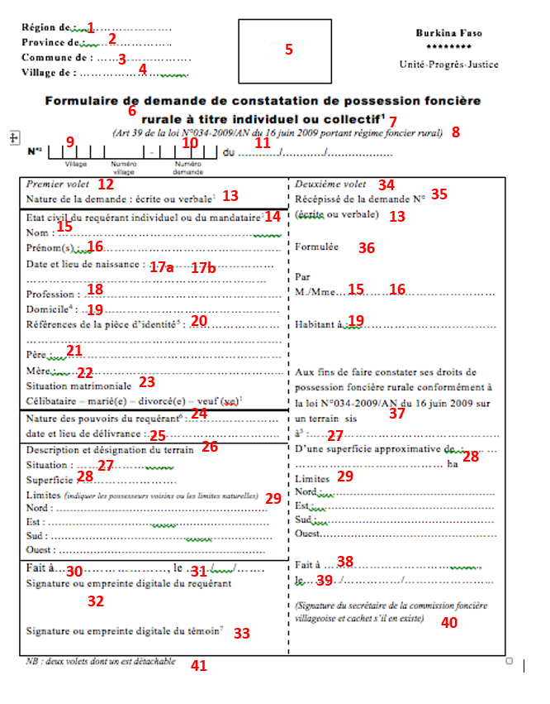

### Form 2: Formulaire de Mandat pr demande collective\_final\_KDG\_validé Mandate for collective application)

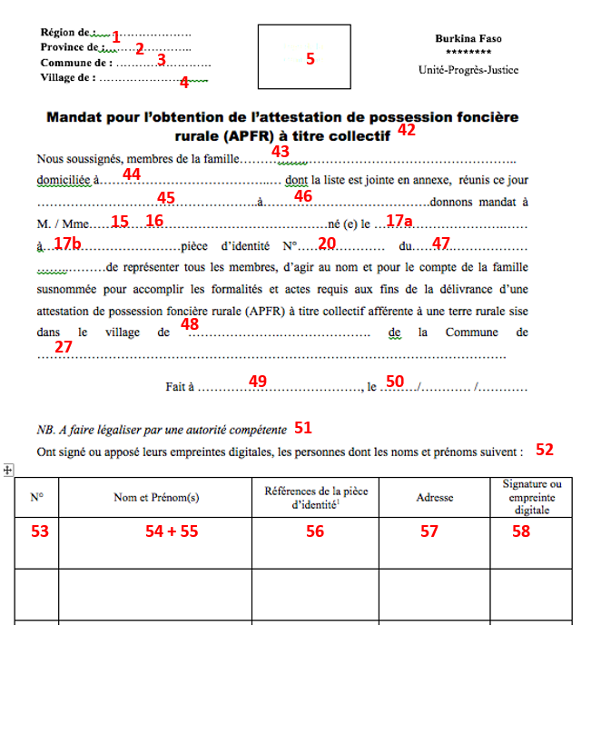

### Form 3: Formulaire\_avis\_publicté foncière\_final\_KDG\_validé (Public Notice)

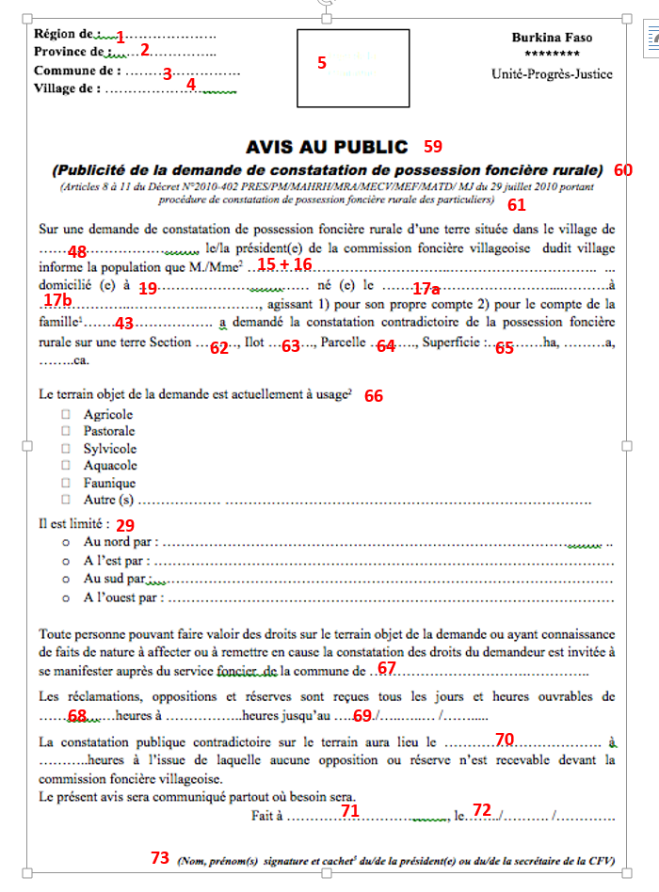

### Form 7: PV de Constatation Contradictoire

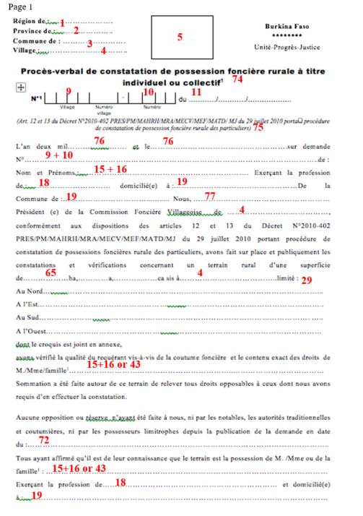

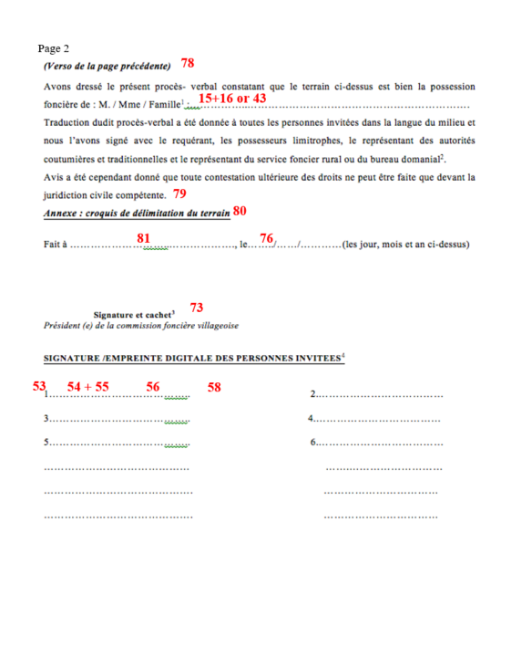

### Form 5. Fomulaire\_Attest\_Poss\_Fonc\_ individuelle initiale\_final\_KDG\_validé (Individual APFR)

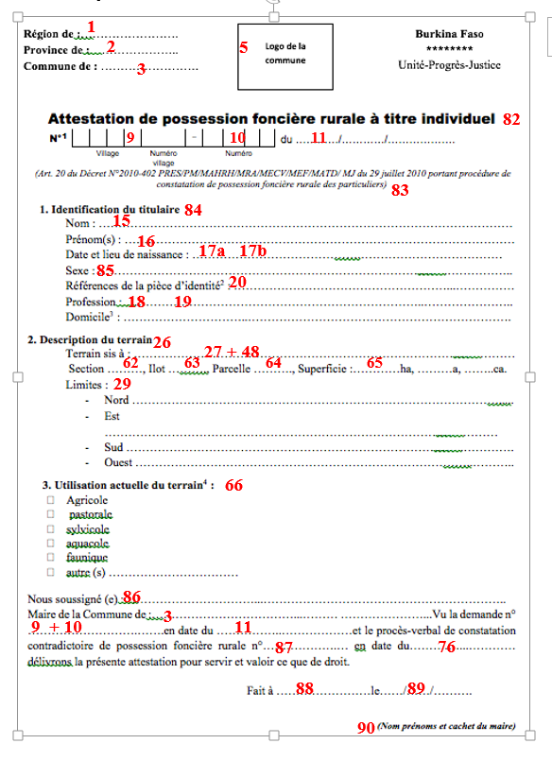

### Form 8: Formulaire Attest\_Poss\_Fon\_Rurale\_collective\_final\_KDG\_validé (Collective APFR)

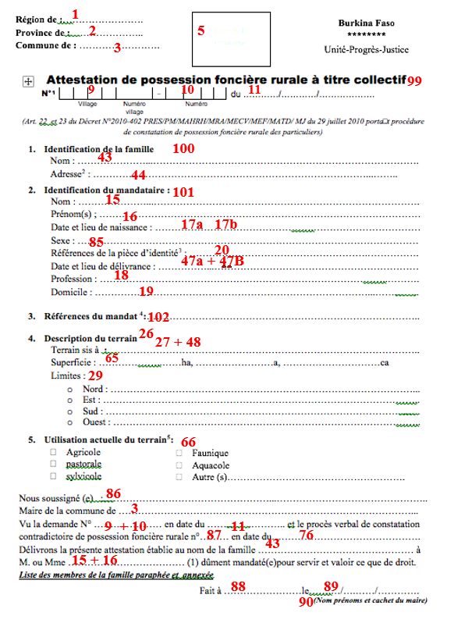

## Attributes of key Land Forms

| **Nb** | **Description** | **French (in form)** | **English** |
| --- | --- | --- | --- |
| **Form 1** | | | |
| 1 | Description of the region. In 1 region is several Provinces. See Excel document | Région de | Region |
| 2 | Description of the province. In 1 province is several Communes. See Excel document | Province de | Province |
| 3 | Description of the Commune. In 1 Commune is several Villages. See Excel document | Commune de | Commune |
| 4 | Description of the Village. In 1 Village is several Sub-villages. See Excel document | Village de | Village |
| 5 | Logo of the Commune |  |  |
| 6 | Title of the form | Demande de constatation de possession foncière rurale à titre individuel ou collectif |  |
| 7 | Applicants need to put a line as appropriate between an individual application or a collective application. Choices are :   * Individual * Collective | * Demande à titre individuel * Demande à titre collectif | * Individual application * Collective application |
| 8 | Reference to the law | *(Art 39 de la loi N°034-2009/AN du 16 juin 2009 portant régime foncier rural)* |  |
| 9 | Village number xx digits. See Excel document | Numéro de village | Village Number |
| 10 | Application number at the SFR level. To be discussed with SFR during the trip to Boudry unless Médard has en idea | Numéro de demande | Application number |
| 11 | Date of application : DD/MM/YYYY | Date de la demande | Date of application |
| 12 | Title of the first section of the form; left part | *Premier volet* | First section |
| 13 | Request if the application is written or Verbal. Applicants need to put a line as appropriate between Written or Verbal.  If it is verbal, a witness needs to assist the applicant and sign the documents. | Nature de la demande :   * Ecrite * Verbale | Nature of the application :   * Written * Verbal |
| 14 | Title of the subsection of section 1 of the form | Etat civil du requérant individuel ou du mandataire | Personnal information |
| 15 | The applicant (which can be the representative of the collective application) provides his/her last name | Nom | Surname |
| 16 | The applicant provides his/her last firs name or names if several | Prénom(s) | First name(s) |
| 17a  17b | The applicant provides his/her birth date (17a) and commune of birth (17b) which is normally written on the birth certificate. | Date et lieu de naissance | Birth date and place of birth |
| 18 | The applicant provides his/her profession | Profession | Profession |
| 19 | The applicant provides his/her address as accurate as possible. Postal codes exist in Burkina and should be used in MAST but house numbers and street names are not always defined. It can also be hamlet names. | Domicile | Personal address |
| 20 | The applicant provides the reference number of his/her ID card. | Références de la pièce d’identité | Reference of identity card |
| 21 | The applicant provides his/her father first and last names | Père | Father |
| 22 | The applicant provides his/her mother first and last name | Mère | Mother |
| 23 | The applicant provides his/her marital status. Multiple choice where the applicant needs to put a line as appropriate between Single, Married, Divorced or Widowed | Situation matrimoniale :   * Célibataire * Marié(e) * Divorcé(e) * Veuf (ve) | Marital status :   * Single * Married * Divorced * Widowed |
| 24 | The applicant describes if he has a mandate in case of collective application or a power of attorney in case of a minor or an adult under tutorship. | Nature des pouvoirs du requérant :   * Aucun * Mandat * Procuration | Nature of the powers of the applicant :   * None * Mandate * Power of Attorney |
| 25 | If there is a mandate or a power of attorney, the applicant must specify the date and location of the issuance of the document | Date et lieu de délivrance | Issuance date and location |
| 26 | Title annoucing this new subsection of Section 1 | Description et désignation du terrain | Description and designation of the parcel |
| 27 + 48 | Describes the location of the parcel : commune (27), village (48), sub-village if any | Situation | Location |
| 28 | Describes the approximate area of the land parcel | Superficie | Area |
| 29 | The applicants should describe the name of the owners of the neighboring parcels or the natural features. | Limites *(indiquer les possesseurs voisins ou les limites naturelles)* :   * Nord * Est * Sud * Ouest | Limits (indicate the neighboring land possessors or natural limits) :   * North * East * South * West |
| 30 | Describes the commune of application | Fait à | Applied at |
| 31 | Describes the date of application: DD/MM/YYYY | Le | Date |
| 32 | The applicant should sign or apply his/her finger print below this line | Signature ou empreinte digitale du requérant | Signature of finger print of the applicant |
| 33 | The witness should sign or apply his/her finger print below this line. This only applies if the application is verbal. | Signature ou empreinte digitale du témoin | Signature of finger print of the witness |
| 34 | Title of the second section of the form; right part  The CFV agent actually copies some of the information that have been written in section 1. | *Deuxième volet* | Second section |
| 35 | The CFV agent should actually add the application number here. This should be the same as in the APFR registry at the SFR level. | Récipissé de la demande N° | Receipt of the application number : |
| 13 | The SFR agent puts a line as appropriate between Written or Verbal and according to what was mention in Section 1 | (écrite ou verbale) | * (written or verbal) |
| 36 | Static field | Formulée par | Expressed by |
| 15 + 16 | Here, the CFV agent rewrites the first and last name of the applicant | M./Mme | Mr or Mrs |
| 19 | The CFV member copies the personal address of the applicant | Habitant à : | Living at : |
| 37 | Static field | Aux fins de faire constater ses droits de possession foncière rurale conformément à la loi N°034-2009/AN du 16 juin 2009 sur un terrain sis | For the purposes having the rural land possession rights recognized in accordance with law No. 034-2009 / AN of 16 June 2009 on a land located |
| 27 | The CFV member copies the commune and village | à | at |
| 28 | The CFV member copies the approximate area oof the land declared by the applicant | D’une superficie approximative de  …. ha | Of an approximate area of …. hectares |
| 29 | The applicants copies the description and designation of the land | Limites *(indiquer les possesseurs voisins ou les limites naturelles)* :   * Nord * Est * Sud * Ouest | Limits (indicate the neighboring land possessors or natural limits) :   * North * East * South * West |
| 38 | Describes the commune of application | Fait à | Applied at |
| 39 | Describes the date of application: DD/MM/YYYY | Le | On |
| 40 | The CVF member, actually the secretary of the CFV if any, should sign or apply his/her finger print below this line | *(Signature du secrétaire de la commission foncière villageoise et cachet s’il en existe)* | (Signature of the secretary of the village land council if any) |
| 41 | Mention | *NB : deux volets dont un est détachable* | Two sections including one detachable section (section 2) |
|  |  |  |  |
|  | **Form 2**  **This for mis use dis the APFR application is done collectively, thus for a family** | | |
| 42 | Title of the form | Mandat pour l’obtention de l’attestation de possession foncière rurale (APFR) à titre collectif | Mandate for obtaining the collective APFR |
| 43 | The … should be replaced by the family name. The family may most likely to be the same as the last name of the applicant (attribute 15), but may also be different. | Nous soussignés, membres de la famille…… | We undersigned, members of the family…. |
| 44 | The … should be replaced by the address where the family lives. The address may most likely to be the personal address of the applicant (attribute 19), but may also be different. | domiciliée à…… | Living at… |
| 45 | The … should be replaced by the date when the mandate is drafted : DD/MM/YYYY | dont la liste est jointe en annexe, réunis ce jour ……… | Including the appended document … |
| 46 | The … should be replaced by the commune where the family is located when drafting the mandate | à … | At … |
| 15 + 16 | The … should be replaced by the first and last name of the applicant | donnons mandat à M. / Mme…… | Are giving mandate to Mr / Mrs … |
| 17a | The … should be replaced by the birth date of the applicant | né (e) le … | Born on … |
| 17b | The … should be replaced by the birth place of the applicant | à … | at … |
| 20 | The … should be replaced by the ID card number of the applicant | pièce d’identité N°… | ID number … |
| 47 | The … should be replaced by the applicant’s ID card establishment date : DD/MM/YYYY | du… | From… |
| 48 | Describes the village where the parcel is located within the commune (next) and sub-village if any. | de représenter tous les membres, d’agir au nom et pour le compte de la famille susnommée pour accomplir les formalités et actes requis aux fins de la délivrance d’une attestation de possession foncière rurale (APFR) à titre collectif afférente à une terre rurale sise dans le village de … | to represent all members, to act for and on behalf of the above named family to complete the formalities and acts required for the issuance of a certificate of rural land possession (APFR) collectively relating to the rural land located in the village of ... |
| 27 | Describes the commune where the parcel is located. Should be attribute 27 | de la Commune de … | At the commune of … |
| 49 | Describes the commune where the draft of the mandate was made | Fait à | Applied at |
| 50 | Describes the date when the mandate was made : DD/MM/YYYY | Le | Date |
| 51 | Mention | *NB. A faire légaliser par une autorité compétente* |  |
| 52 | Mention | Ont signé ou apposé leurs empreintes digitales, les personnes dont les noms et prénoms suivent : |  |
| 53 | Describes the family member’s number in the list of applicants | N° | Number |
| 54 + 55 | Each family member should provide his/her last name (54) and first name(s) (55) | Nom et Prénom(s) | Last name and first name(s) |
| 56 | Describes the ID card number. It can be National ID card, Passport, Military card, or National driving license. | Références de la pièce d’identité | Reference of the ID Card |
| 57 | Describes the personal address of each family member | Adresse | Personnal Address |
| 58 | Each family member should sign or apply a finger print for the mandate to be valid. | Signature ou empreinte digitale | Signature or finger print |
|  |  |  |  |
|  | **Form 3 – Public Notice** |  |  |
| 59 | Mention | AVIS AU PUBLIC | PUBLIC NOTICE |
| 60 | Mention | ***(Publicité de la demande de constatation de possession foncière rurale)*** | Public notice of the application for APFR |
| 61 | Reference to the Law 034-2009 | (Articles 8 à 11 du Décret N°2010-402 PRES/PM/ MAHRH/MRA/ MECV/MEF/ MATD/ MJ du 29 juillet 2010 portant procédure de constatation de possession foncière rurale des particuliers) |  |
| 48 | Describes the village where the parcel is located within the commune | Sur une demande de constatation de possession foncière rurale d’une terre située dans le village de … |  |
| 15 + 16 | The … should be replaced by the first and last name of the applicant. The choice between Mr or Mrs should also be chosen by putting a line throught the wrong choice. | le/la président(e) de la commission foncière villageoise dudit village informe la population que M./Mme2 … | The president of the CFV of the said village inform the population that Mr/Mme … |
| 19 | The applicant’s address should be added. | domicilié (e) à … | Living at … |
| 17a | The … should be replaced by the birth date of the applicant | né (e) le … | Born on … |
| 17b | The … should be replaced by the birth place of the applicant | à … | At … |
| 43 | If individual, the choice should be made for 1) and a line should be put through 2).  If collective, the choice should be doen for 2), a line should be put through 1) and the … should be replaced by the family name (43). | Agissant :   1. pour son propre compte 2. pour le compte de la famille[[1]](#footnote-1)… | Acting:   1. for himself/ herself 2. on behalf of the family … |
| 62 | The … should be replaced by the Section provided by the DPI/Cadastral Department | a demandé la constatation contradictoire de la possession foncière rurale sur une terre Section … | has requested the contradictory registration of the rural land possession of a land Section … |
| 63 | The … should be replaced by the Lot provided by the DPI/Cadastral Department | Ilot … | Lot… |
| 64 | The … should be replaced by the Parcel number provided by the DPI/Cadastral Department | Parcelle … | Parcel… |
| 65 | The … should be replaced by the Area measured during the field operation: hectares, areas, centiares | Superficie :…………ha ………a ……..ca. | Area: ……… hectares ….. ares …… centiares |
| 66 | This describes the current destination of the land | Le terrain objet de la demande est actuellement à usage[[2]](#footnote-2)   * Agricole * Pastorale * Sylvicole * Aquacole * Faunique * Autre (s) … | The destination of the land is currently:   * Agricultural * Pastoral * Sylvicultural * Aquacultural * Fauna * Other, please mention |
| 29 | The applicants copies the description and designation of the land unless the survey has shown differently | Il est limité :   * Au nord par : … * A l’est par : … * Au sud par : … * A l’ouest par : … |  |
| 27 | Requests if anyone has something to say about this application. The … should be replaced by the commune of application. | Toute personne pouvant faire valoir des droits sur le terrain objet de la demande ou ayant connaissance de faits de nature à affecter ou à remettre en cause la constatation des droits du demandeur est invitée à se manifester auprès du service foncier de la commune de … | Anyone who wish to claim rights on the land applied for or with knowledge of facts likely to affect, or to question the finding of the applicant's rights is invited to come forward to the SFR of the commune of ... |
| 68 | Describes when complaints etc. should be expressed: the … should be replaced by the start hour and end hour of the opening hours | Les réclamations, oppositions et réserves sont reçues tous les jours et heures ouvrables de …………..…heures à ……………..heures | Any complaints, objections and reservations are received on all working days and open hours from ............ to ….. |
| 69 | Describes the end date of the public notice | jusqu’au …....…/…..…..… /……..... | Until DD/MM/YYYY |
| 70 | Describes the date and time of the contradictory survey. | La constatation publique contradictoire sur le terrain aura lieu le ……………………………. à ………..heures à l’issue de laquelle aucune opposition ou réserve n’est recevable devant la commission foncière villageoise.  Le présent avis sera communiqué partout où besoin sera. | The contradictory public recognition in the field will be held on …(date DD/MM/YYYY) at … (time) after which no opposition or reservation is admissible before the village land commission. This notice will be provided wherever necessary . |
| 71 | Describes the commune (and village) of issuance of the public notice | Fait à | Applied at |
| 72 | Describes the date of Public notice issuance: DD/MM/YYYY | Le | Date |
| 73 | The CFV President or secretary should add his last name, first name, sign and add the stamp of the CFV | ***(Nom, prénom(s) signature et cachet[[3]](#footnote-3) du/de la président(e) ou du/de la secrétaire de la CFV)*** | (Last name, First name(s), signature and stamp (if possible) of the president ou the secretary of the CVF |
|  |  |  |  |
| **Form 7 - Official report ascertaining the rural land possession individually or collectively** | | | |
|  | Page 1 |  |  |
| 74 | Title of the form | Procès-verbal de constatation de possession foncière rurale à titre individuel ou collectif |  |
| 75 | Reference to the law 034-2009 | (Art. 12 et 13 du Décret N°2010-402 PRES/PM/ MAHRH/MRA/MECV/ MEF/MATD/ MJ du 29 juillet 2010 portant procédure de constatation de possession foncière rurale des particuliers) |  |
| 76 | Describes the date fully written  First … being the year  Second … being the day and month | L’an deux mil… et le… | On (Month) (day) two thousand (year) |
| 9 + 10 | Describes the application number as on top of the form. Médard, can you confirm? | N° | Number |
| 15 + 16 | Describes the last name and first name(s) of the applicant | de :  Nom et Prénoms :… | From Last name and First name(s) |
| 18 | Describes the profession of the applicant | Exerçant la profession de :… | Practicing the occupation of:… |
| 19 | Describes the personal address of the applicant including street address if any, village, and commune | domicilié(e) à :… De la Commune de : … | Living at:… from the commune of… |
| 77 | Describes the name(s) of the president of the CFV | Nous, … | We, … |
| 4 | Describes the commune and village of the CFV | Président (e) de la Commission Foncière Villageoise de … | President of the CFV of … |
| 65 | Describes the area of the surveyed parcel | conformément aux dispositions des articles 12 et 13 du Décret N°2010-402 PRES/PM/MAHRH/ MRA/MECV/MEF/ MATD/MJ du 29 juillet 2010 portant procédure de constatation de possessions foncières rurale des particuliers, avons fait sur place et publiquement les constatations et vérifications concernant un terrain rural d’une superficie de………………ha, …………a, …...……ca | in accordance with Articles 12 and 13 of Decree No. 2010-402 PRES / PM / MAHRH / MRA / MECV / MEF / MATD / MJ of 29 July 2010 on the procedure for recognition of rural land possession of individuals, have made on-site and publicly the findings and verifications of rural land with an area of .................. hectares ............ ares ......... ... ...... centiares |
| 4 | Describes the commune and village where the parcel is located which should be the same as the CFV but different from applicant | sis à… | Located at … |
| 29 |  | limité :  Nord  Est  Sud  Ouest | Which limits are:  North  East  South  West |
| 15 + 16  or  43 | Describes the fact that the SFR has made the necessary research in the field to approve the right of the applicant(s). There is a choice to make regarding the type of applicant by putting a line through the wrong answers between Mr. Mrs. Or family. The … should be replaced by the last and first names of the applicant of the name of the family. | dont le croquis est joint en annexe,  avons vérifié la qualité du requérant vis-à-vis de la coutume foncière et le contenu exact des droits de M./Mme/famille… | Of which the boundary map in attached in annex,  Have verified the quality of the applicant regarding the customary land and the exact content od the rights of Mr/Mrs/Familly … |
| 72 | Describes the fact that no objection was made since Public notice issuance: DD/MM/YYYY | Sommation a été faite autour de ce terrain de relever tous droits opposables à ceux dont nous avons requis d’en effectuer la constatation.  Aucune opposition ou réserve n’ayant été faite à nous, ni par les notables, les autorités traditionnelles et coutumières, ni par les possesseurs limitrophes depuis la publication de la demande en date du :… | Demand was served around the land to survey all rights against those we are required to make a finding. No objection or reservation having been made ​​to us, either by community leaders, traditional and customary authorities, or by neighboring owners since the publication of the application dated ... |
| 15 + 16  or  43 | Describes the fact that all parties recognize the rights of the applicant(s). There is a choice to make regarding the type of applicant by putting a line through the wrong answers between Mr. Mrs. Or family. The … should be replaced by the last and first names of the applicant of the name of the family. | Tous ayant affirmé qu’il est de leur connaissance que le terrain est la possession de M. /Mme ou de la famille : … | All expressing their knowledge about the land belonging to Mr/Mrs/Family: … |
| 18 | Describes the profession of the applicant | Exerçant la profession de :… | Practicing the occupation of:… |
| 19 | Describes the personal address of the applicant including street address if any, village, and commune | à :… | at:… |
|  | Page 2 |  |  |
| 78 | Mention explaining it was the following of the previous page | (Verso de la page précédente) | Verso of the previous page |
| 15 + 16  or  43 | Describes the fact that the CFV can establish the rights of the applicants. There is a choice to make regarding the type of applicant by putting a line through the wrong answers between Mr. Mrs. Or family. The … should be replaced by the last and first names of the applicant of the name of the family. | Avons dressé le présent procès- verbal constatant que le terrain ci-dessus est bien la possession foncière de : M. / Mme / Famille :… | Have compiled this minutes stating that the land above mentioned is land possession of: Mr/Mrs/Family |
| 79 | mention | Traduction dudit procès-verbal a été donnée à toutes les personnes invitées dans la langue du milieu et nous l’avons signé avec le requérant, les possesseurs limitrophes, le représentant des autorités coutumières et traditionnelles et le représentant du service foncier rural ou du bureau domanial.  Avis a été cependant donné que toute contestation ultérieure des droits ne peut être faite que devant la juridiction civile compétente. | Translation of the report was given to all those invited in the local language and we have signed with the applicant, neighboring owners , the representative of customary and traditional authorities and the representative of rural land service or federal office .  Opinion was given however that any subsequent dispute of rights can only be made before the competent civil court. |
| 80 | Specifies that the boundary mapping is in annex | Annexe : croquis de délimitation du terrain | Boundary map in annex |
| 81 | Describes the commune (and village) of issuance of the recognition of the rights | Fait à | Applied at |
| 76 | Describes the date of the recognition of the rights: DD/MM/YYYY | Le | Date |
| 73 | The CFV President should sign and add the stamp of the CFV | Signature et cachet du/de la président(e) de la CFV) | Signature and stamp (if possible) of the president of the CVF |
| 53 + 54 +  55 + 56+ 58 | Each family member should add his/her first and last names, ID card number, and sign or apply a finger print for the mandate to be valid.  Each member should use the same number as registered on the mandate in Form 2. | SIGNATURE / EMPREINTE DIGITALE DES PERSONNES INVITEES | Signature/Finger print of |
|  |  |  |  |
|  | **Form 5 – APFR for individual** |  |  |
| 1 | Description of the region. In 1 region is several Provinces. See Excel document | Région de | Region |
| 2 | Description of the province. In 1 province is several Communes. See Excel document | Province de | Province |
| 3 | Description of the Commune. In 1 Commune is several Villages. See Excel document | Commune de | Commune |
| 5 | Logo of the Commune |  |  |
| 82 | Title | Attestation de possession foncière rurale à titre individuel | APFR for individual |
| 9 | Village number xx digits. See Excel document | Numéro de village | Village Number |
| 10 | Application number at the SFR level. To be discussed with SFR during the trip to Boudry unless Médard has en idea | Numéro de demande | Application number |
| 11 | Date of application : DD/MM/YYYY | Date de la demande | Date of application |
| 83 | Reference to the law | (Art. 20 du Décret N°2010-402 PRES/PM/MAHRH/ MRA/MECV/MEF/ MATD/ MJ du 29 juillet 2010 portant procédure de constatation de possession foncière rurale des particuliers) |  |
| 84 | Title of the section 1 of the APFR document | Identification du titulaire | Identification of the possessor |
| 15 | The possessor’s last name. (There is no mention of a power of attorney here) | Nom | Surname |
| 16 | The possessor’s first names | Prénom(s) | First name(s) |
| 17a  17b | The possessor’s birth date (17a) and commune of birth (17b). | Date et lieu de naissance | Birth date and place of birth |
| 85 | Instead of Mr or Mrs, it is necessary to specify the gender | Sexe :  Femme  Homme | Gender:  Female  Male |
| 20 | The possessor’s ID card number. | Références de la pièce d’identité | Reference of identity card |
| 18 | The possessor’s profession | Profession | Profession |
| 19 | The possessor’s personal address | Domicile | Personal address |
| 26 | Title of section 2 of the document about the description of the lad | Description du terrain | Description of the parcel |
| 27 + 48 | Describes the location of the parcel : commune (27), village (48), sub-village if recorded | Terrain sis à : … | Location |
| 62 | The … should be replaced by the Section provided by the DPI/Cadastral Department | a demandé la constatation contradictoire de la possession foncière rurale sur une terre Section … | has requested the contradictory registration of the rural land possession of a land Section … |
| 63 | The … should be replaced by the Lot provided by the DPI/Cadastral Department | Ilot … | Lot… |
| 64 | The … should be replaced by the Parcel number provided by the DPI/Cadastral Department | Parcelle … | Parcel… |
| 65 | The … should be replaced by the Area measured during the field operation: hectares, areas, centiares | Superficie :…………ha ………a ……..ca. | Area: ……… hectares ….. ares …… centiares |
| 29 | The possessor should describe the name of the owners of the neighboring parcels or the natural features. | Limites:  Nord  Est  Sud  Ouest | Limits:  North  East  South  West |
| 66 | This describes the current destination of the land | Utilisation actuelle du terrain  Agricole  Pastorale  Sylvicole  Aquacole  Faunique  Autre (s) … | Current use of the land:  Agricultural  Pastoral  Sylvicultural  Aquacultural  Fauna  Other, please mention |
| 86 | The … should be replaced by the name of the mayor | Nous soussigné (e) : … | We undersigned: … |
| 3 | The … should be replaced by the name of the commune of the SFR | Maire de la Commune de :… | Mayor of the commune of |
| 9 + 10 | Village number xx digits. See Excel document  Application number at the SFR level. To be discussed with SFR during the trip to Boudry unless Médard has en idea | Vu la demande n° … | Looking at application number: … |
| 11 | Date of application : DD/MM/YYYY | en date du … | From |
| 87 | The … should be replaced by the PV number but we need to confirm with Médard which number it is | et le procès-verbal de constatation contradictoire de possession foncière rurale n°… | And the official report of contradictory assessment of rural land possession Number… |
| 76 | Describes the date of the recognition of the rights: DD/MM/YYYY | En date du :… | From… |
|  | End of text | délivrons la présente attestation pour servir et valoir ce que de droit. | deliver this certificate to serve and to assert that right. |
| 88 | Describes the commune of issuance of the APFR | Fait à | done at |
| 89 | Describes the date of APFR issuance: DD/MM/YYYY | Le | Date |
| 90 | The Mayor should add his last name, first name, sign and add the stamp of the Commune | (Nom, prénom(s) et cachet du maire) | (Last name, First name(s), signature and stamp of the mayor |
|  |  |  |  |
|  |  |  |  |
|  | ~~Form 6 – APFR for individual following a mutation~~ |  |  |
| ~~1~~ | ~~Description of the region. In 1 region is several Provinces. See Excel document~~ | ~~Région de~~ | ~~Region~~ |
| ~~2~~ | ~~Description of the province. In 1 province is several Communes. See Excel document~~ | ~~Province de~~ | ~~Province~~ |
| ~~3~~ | ~~Description of the Commune. In 1 Commune is several Villages. See Excel document~~ | ~~Commune de~~ | ~~Commune~~ |
| ~~5~~ | ~~Logo of the Commune~~ |  |  |
| ~~91~~ | ~~Title~~ | ~~Attestation de possession foncière rurale à titre individuel~~  ~~(Suite à une mutation)~~ | ~~APFR for individual~~  ~~(following a mutation)~~ |
| ~~9~~ | ~~Village number xx digits. See Excel document~~ | ~~Numéro de village~~ | ~~Village Number~~ |
| ~~10~~ | ~~Application number at the SFR level. To be discussed with SFR during the trip to Boudry unless Médard has en idea~~ | ~~Numéro de demande~~ | ~~Application number~~ |
| ~~11~~ | ~~Date of application : DD/MM/YYYY~~ | ~~Date de la demande~~ | ~~Date of application~~ |
| ~~92~~ | ~~Reference to the law~~ | ~~(Art. 20 du Décret N°2010-402 PRES/PM/MAHRH/ MRA/MECV/MEF/ MATD/ MJ du 29 juillet 2010 portant procédure de constatation de possession foncière rurale des particuliers)~~ |  |
| ~~84~~ | ~~Title of the section 1 of the APFR document~~ | ~~Identification du titulaire~~ | ~~Identification of the possessor~~ |
| ~~15~~ | ~~The possessor’s last name. (There is no mention of a power of attorney here)~~ | ~~Nom~~ | ~~Surname~~ |
| ~~16~~ | ~~The possessor’s first names~~ | ~~Prénom(s)~~ | ~~First name(s)~~ |
| ~~17a~~  ~~17b~~ | ~~The possessor’s birth date (17a) and commune of birth (17b).~~ | ~~Date et lieu de naissance~~ | ~~Birth date and place of birth~~ |
| ~~85~~ | ~~Instead of Mr or Mrs, it is necessary to specify the gender~~ | ~~Sexe :~~  ~~Femme~~  ~~Homme~~ | ~~Gender:~~  ~~Female~~  ~~Male~~ |
| ~~18~~ | ~~The possessor’s profession~~ | ~~Profession~~ | ~~Profession~~ |
| ~~19~~ | ~~The possessor’s personal address~~ | ~~Domicile~~ | ~~Personal address~~ |
| ~~20~~ | ~~The possessor’s ID card number.~~ | ~~Références de la pièce d’identité~~ | ~~Reference of identity card~~ |
| ~~47~~ | ~~The … should be replaced by the possessor’s ID card establishment date (47a) : DD/MM/YYYY and place (47b)~~ | ~~Date et lieu de délivrance : …~~ | ~~Date and place of issuance…~~ |
| ~~26~~ | ~~Title of section 2 of the document about the description of the lad~~ | ~~Description du terrain~~ | ~~Description of the parcel~~ |
| ~~27 + 48~~ | ~~Describes the location of the parcel : commune (27), village (48), sub-village if recorded~~ | ~~Terrain sis à : …~~ | ~~Location~~ |
| ~~62~~ | ~~The … should be replaced by the Section provided by the DPI/Cadastral Department~~ | ~~a demandé la constatation contradictoire de la possession foncière rurale sur une terre Section …~~ | ~~has requested the contradictory registration of the rural land possession of a land Section …~~ |
| ~~63~~ | ~~The … should be replaced by the Lot provided by the DPI/Cadastral Department~~ | ~~Ilot …~~ | ~~Lot…~~ |
| ~~64~~ | ~~The … should be replaced by the Parcel number provided by the DPI/Cadastral Department~~ | ~~Parcelle …~~ | ~~Parcel…~~ |
| ~~65~~ | ~~The … should be replaced by the Area measured during the field operation: hectares, areas, centiares~~ | ~~Superficie :…………ha ………a ……..ca.~~ | ~~Area: ……… hectares ….. ares …… centiares~~ |
| ~~29~~ | ~~The possessor should describe the name of the owners of the neighboring parcels or the natural features.~~ | ~~Limites:~~  ~~Nord~~  ~~Est~~  ~~Sud~~  ~~Ouest~~ | ~~Limits:~~  ~~North~~  ~~East~~  ~~South~~  ~~West~~ |
| ~~66~~ | ~~This describes the current destination of the land~~ | ~~Utilisation actuelle du terrain~~  ~~Agricole~~  ~~Pastorale~~  ~~Sylvicole~~  ~~Aquacole~~  ~~Faunique~~  ~~Autre (s) …~~ | ~~Current use of the land:~~  ~~Agricultural~~  ~~Pastoral~~  ~~Sylvicultural~~  ~~Aquacultural~~  ~~Fauna~~  ~~Other, please mention~~ |
| ~~86~~ | ~~The … should be replaced by the name of the mayor~~ | ~~Nous soussigné (e) : …~~ | ~~We undersigned: …~~ |
| ~~3~~ | ~~The … should be replaced by the name of the commune of the SFR~~ | ~~Maire de la Commune de :…~~ | ~~Mayor of the commune of~~ |
| ~~93~~ | ~~The … should be replaced by the number of the former APFR.~~ | ~~Vu l’attestation de possession foncière rurale n° …~~ | ~~Seen the certificate of rural land possession No ...~~ |
| ~~89~~ | ~~Describes the date of the former APFR signature by the mayor: DD/MM/YYYY~~ | ~~En date du :…~~ | ~~From…~~ |
| ~~94~~ | ~~Describes the mutation type. So far it could a sale, donation, inheritance through filiation, etc.~~ | ~~et l’acte[[4]](#footnote-4) de …~~ | ~~And the act from: …~~ |
| ~~95~~ | ~~Describes the registration number of the act if any~~ | ~~N° : …~~ | ~~Number: …~~ |
| ~~96~~ | ~~The … should be replaced by the dat of establishment of the act: DD/MM/YYYY~~ | ~~En date du …~~ | ~~From …~~ |
|  | ~~End of text~~ | ~~délivrons la présente attestation pour servir et valoir ce que de droit.~~ | ~~deliver this certificate to serve and to assert that right~~ |
| ~~97~~ | ~~Describes the commune of issuance of the APFR~~ | ~~Fait à~~ | ~~done at~~ |
| ~~98~~ | ~~Describes the date of APFR issuance: DD/MM/YYYY~~ | ~~Le~~ | ~~Date~~ |
| ~~90~~ | ~~The Mayor should add his last name, first name, sign and add the stamp of the Commune~~ | ~~(Nom, prénom(s) et cachet du maire)~~ | ~~(Last name, First name(s), signature and stamp of the mayor~~ |
|  |  |  |  |
|  |  |  |  |
| **Form 8 – APFR for collective** | | | |
| 1 | Description of the region. In 1 region is several Provinces. See Excel document | Région de | Region |
| 2 | Description of the province. In 1 province is several Communes. See Excel document | Province de | Province |
| 3 | Description of the Commune. In 1 Commune is several Villages. See Excel document | Commune de | Commune |
| 5 | Logo of the Commune |  |  |
| 99 | Title | Attestation de possession foncière rurale à titre collectif | APFR for collective |
| 9 | Village number xx digits. See Excel document | Numéro de village | Village Number |
| 10 | Application number at the SFR level. To be discussed with SFR during the trip to Boudry unless Médard has en idea | Numéro de demande | Application number |
| 11 | Date of application : DD/MM/YYYY | Date de la demande | Date of application |
|  | Reference to the law | (Art. 20 du Décret N°2010-402 PRES/PM/MAHRH/ MRA/MECV/MEF/ MATD/ MJ du 29 juillet 2010 portant procédure de constatation de possession foncière rurale des particuliers) |  |
| 100 | Title of the section 1 of the APFR document | Identification de la famille | Identification of the family |
| 43 | Describes the name of the family | Nom | Name |
| 44 | Describes the address of the family | Adresse | Address |
| 101 | Describes the title of the section for the person having the mandate | Identification du mandataire | Identification of the representative |
| 15 | The possessor’s last name. (There is no mention of a power of attorney here) | Nom | Surname |
| 16 | The possessor’s first names | Prénom(s) | First name(s) |
| 17a  17b | The possessor’s birth date (17a) and commune of birth (17b). | Date et lieu de naissance | Birth date and place of birth |
| 85 | Instead of Mr or Mrs, it is necessary to specify the gender | Sexe :  Femme  Homme | Gender:  Female  Male |
| 20 | The possessor’s ID card number. | Références de la pièce d’identité | Reference of identity card |
| 47 | The … should be replaced by the possessor’s ID card establishment date (47a) : DD/MM/YYYY and place (47b) | Date et lieu de délivrance : … | Date and place of issuance… |
| 18 | The possessor’s profession | Profession | Profession |
| 19 | The possessor’s personal address | Domicile | Personal address |
| 102 | Describes the reference of the mandate. Need to ask which one | Références du mandat | Reference of the mandate |
| 26 | Title of section 2 of the document about the description of the lad | Description du terrain | Description of the parcel |
| 27 + 48 | Describes the location of the parcel : commune (27), village (48), sub-village if recorded | Terrain sis à : … | Location |
| 65 | The … should be replaced by the Area measured during the field operation: hectares, areas, centiares | Superficie :…………ha ………a ……..ca. | Area: ……… hectares ….. ares …… centiares |
| 29 | The possessor should describe the name of the owners of the neighboring parcels or the natural features. | Limites:  Nord  Est  Sud  Ouest | Limits:  North  East  South  West |
| 66 | This describes the current destination of the land | Utilisation actuelle du terrain  Agricole  Pastorale  Sylvicole  Aquacole  Faunique  Autre (s) … | Current use of the land:  Agricultural  Pastoral  Sylvicultural  Aquacultural  Fauna  Other, please mention |
| 86 | The … should be replaced by the name of the mayor | Nous soussigné (e) : … | We undersigned: … |
| 3 | The … should be replaced by the name of the commune of the SFR | Maire de la Commune de :… | Mayor of the commune of |
| 9 + 10 | Village number xx digits. See Excel document  Application number at the SFR level. To be discussed with SFR during the trip to Boudry unless Médard has en idea | Vu la demande n° … | Looking at application number: … |
| 11 | Date of application : DD/MM/YYYY | en date du … | From |
| 87 | The … should be replaced by the PV number but we need to confirm with Médard which number it is | et le procès-verbal de constatation contradictoire de possession foncière rurale n°… | And the official report of contradictory assessment of rural land possession Number… |
| 76 | Describes the date of the recognition of the rights: DD/MM/YYYY | En date du :… | From… |
| 43 | Describes the name of the family | Délivrons la présente attestation établie au nom de la famille … | Deliver this certificate in the name of the family ... |
| 15 + 16 | The possessor’s last name. | à M. ou Mme … | To Mr or Mrs … |
|  | End of text | délivrons la présente attestation pour servir et valoir ce que de droit. | deliver this certificate to serve and to assert that right. |
|  | Describes the fact that it is necessary to add the list of members in annex of the APFR | Liste des membres de la famille paraphée et annexée | List of members of the family initialed and annexed |
| 88 | Describes the commune of issuance of the APFR | Fait à | done at |
| 89 | Describes the date of APFR issuance: DD/MM/YYYY | Le | Date |
| 90 | The Mayor should add his last name, first name, sign and add the stamp of the Commune | (Nom, prénom(s) et cachet du maire) | (Last name, First name(s), signature and stamp of the mayor |
|  |  |  |  |
|  |  |  |  |
|  |  |  |  |

|  |  |  |  |
| --- | --- | --- | --- |
|  |  |  |  |

## Registry Forms

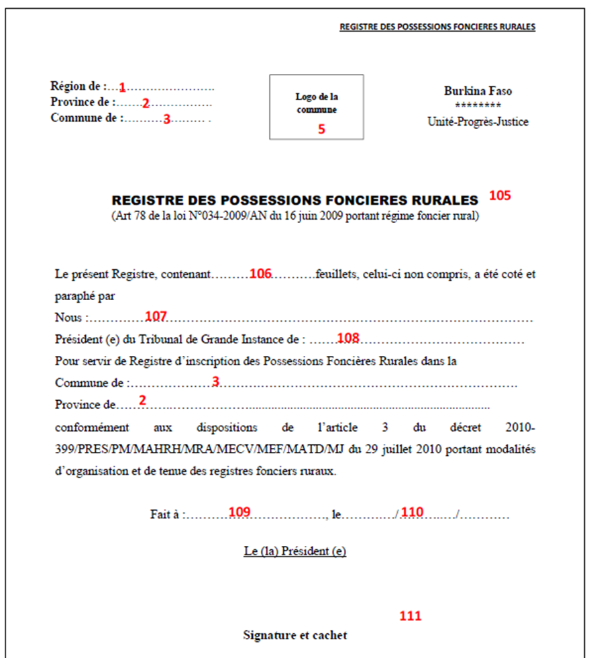

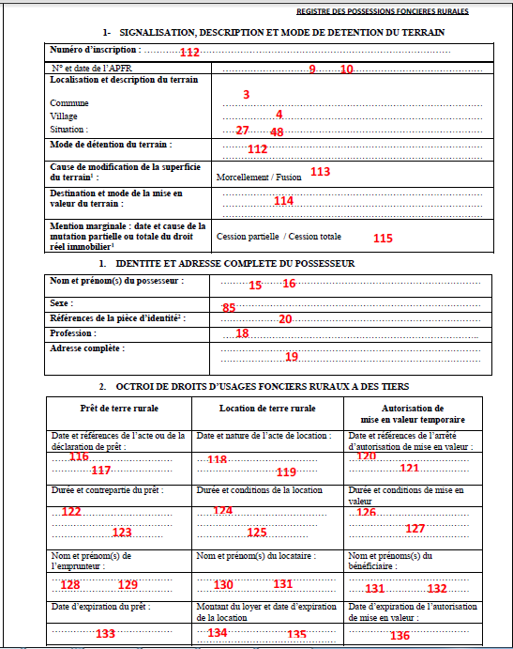

### Attributes of Registry

TBD

| **Nb** | **Description** | **French (in form)** | **English** |
| --- | --- | --- | --- |
| **Form 8 – Registry** | | | |
| 105 | Title | Registre des possessions foncières rurales | Registry of APFR |
| 106 | Number of sheets of the registry | Valeur xxx | Value xxx |
| 107 | Identity of the tribual President | Names of tribunal President | Nom et prenom du president du tribunal de grande instance |
| 108 | Tribunal localisation | Tribunal de Grande Instance de : … | Tribunal of … |
| 109 | The date of the registry issuance | Fait à … | Done at |
| 110 | Date of signature | Le | Date |
| 111 | Signatrue of Tribunal president | Le president | The president |
| 112 | Number of Registry inscription page | Numéro d’inscritpon | Number of inscription |
| 112bis | How people get the land | Mode de detention du terrain | Detention mode |
| 113 | Rasion of area changing | Cause de modification de la superficie du terrain | Cause of area changing |
| 114 | Destination of land | Destination et mode de mise en valeur du terrain | Destination and usage of the land |
| 115 | Date and raison of the land mutation | Date et cause de la mutation | Date and raison of land mutation |
| 116 | Date of rural land loan | Date de la déclaration de prêt | Date of loan |
| 117 | References of rural land loan | Références de la déclaration de prêt | References of rural land loan |
| 118 | Date of lease | Date de l’acte de location | Date of lease |
| 119 | type of lease | Nature de l’acte de location | type of lease |
| 120 | Date of Communal authorization of temporary land enhancement | Date de de l’arrêté de mise en valeur temporaire | Date of Communal authorization of temporary land enhancement |
| 121 | References of Communal authorization of temporary land enhancement | Références de l’arrêté de mise en valeur temporaire | References of Communal authorization of temporary land enhancement |
| 122 | Duration of the loan | Durée du prêt | Duration of the loan |
| 123 | Counterpart of the loan | Contrepartie du prêt | Counterpart of the loan |
| 124 | Duration of the lease | Durée de la location | Duration of the lease |
| 125 | Conditions of the lease | Conditions de la location | Conditions of the lease |
| 126 | Duration of the Communal authorization of temporary land enhancement | Durée de la mise en valeur | Duration of the Communal authorization of temporary land enhancement |
| 127 | Conditions Communal authorization of temporary land enhancement | Conditions de la mise en valeur | Conditions Communal authorization of temporary land enhancement |
| 128 | Last name of the borrower | Nom de l’emprunteur | Last name of the borrower |
| 129 | First name of borrower | Prénom de l’emprunteur | First name of borrower |
| 130 | Last name of the lessee | Nom du locataire | Last name of the lessee |
| 131 | First name of the lessee | Prénom du locataire | First name of the lessee |
| 131bis | Last name of the beneficiary | Nom du locataire | Last name of the beneficiary |
| 132 | First name of the beneficiary | Prénom du locataire | First name of the beneficiary |
| 133 | Expiration date of the loan | Date d’expiration du prêt | Expiration date of the loan |
| 134 | Rent of the lease | Montant du loyer | Rent of the lease |
| 135 | Expiration date of the lease | Date d’expiration de la location | Expiration date of the lease |
| 136 | Expiration date the Communal authorization of temporary land enhancement | Date d’expiration de l’arrêté de mise en valeur temporaire | Expiration date the Communal authorization of temporary land enhancement |
|  |  |  |  |
|  |  |  |  |

1. Rayer la mention inutile [↑](#footnote-ref-1)
2. Cocher la case ou les cases correspondantes [↑](#footnote-ref-2)
3. Si possible [↑](#footnote-ref-3)
4. Préciser si vente, donation, succession, autres [↑](#footnote-ref-4)